3-D SIMULATION OF CONVECTION IN ASYMMETRICALLY HEATED TURBINE BLADE COOLING CHANNELS

Ilker Tari
Mechanical Engineering Department
Middle East Technical University, 06531 Ankara, Turkey

One of the important challenges in gas turbine design is the cooling of the turbine blades due to high operating temperatures. A common approach to this problem is circulating a coolant or cool air in channels bored on the turbine blades. Usually, it is very difficult to perform experiments to obtain information about flow conditions and properties in these channels. I used a home-brewed 3-D spectral methods code to simulate the fluid flow in inclined coolant channels driven by natural as well as forced convection. The channels are taken as asymmetrically heated from the top and the bottom to account for the temperature or heat flux differences. In this abstract, the results for a free convection of water in an inclined channel are given and compared with the horizontal channel case .

INTRODUCTION

The main objective of this study is to simulate fluid flow in an inclined channel of any angle which is asymmetrically heated from the top and the bottom, a kind of flow arrangement that is very common for cooling channels of gas turbine blades. For the numerical simulations, a home-brewed 3-D spectral methods code which is initially developed for the particle motion simulation in horizontal channels ¹ is used.

Computer code

The code uses a spectral methods formulation for the simultaneous solution of Navier-Stokes, thermal energy and small particle equation of motion ². In this study only the flow simulation part is used. This part is known to give exponential accuracy inherent to the spectral methods. The formulations are Fourier Galerkin in streamwise and spanwise directions and Chebyshev Collocation in the vertical direction between the channel walls. The code is modified to allow tilting of the channel to any angle about any axis. Although it is possible to include body forces due to the rotation of blades, they are neglected for this initially study. As a body force, only the gravitation is included. Due to the Boussinesq approximation, variation of all fluid properties other than the density are ignored, therefore buoyancy driven fluid motion can be handled. It is also possible to specify any velocity profile at the entrance of the channel. The code, by default, outputs stream functions, and temperature and velocity fields.

RESULTS

For the presentation in this short abstract, a channel which is inclined with a 30° angle relative to the horizontal axis is considered. The fluid properties are taken at 25°C for water, and the channel is uniformly heated from the bottom. This case is interesting for the hydrodynamic instability created by the bottom heating. For this initial case I did not put any afford to approximate any particular gas turbine design. The objective is to show the concept and obtain some preliminary numerical results for qualitative comparisons.
The results of two separate runs are included in this abstract. The first one is for a horizontal channel uniformly heated from the bottom and the second one is a similar case in every aspect except the 30 degree inclination of the channel relative to the horizontal axis.

Horizontal channel case

In this case, the fluid which is initially quiescent is subjected to uniform heating from the bottom with Ra=20000. The hydrodynamic instability is initiated with a small local numerical disturbance in the temperature field. As a result of this instability, Rayleigh-Benard cells form. The cells tend to oscillate in 3-D. Furthermore, they are not in a regular hexagonal shape due to the lack of boundaries in both streamwise and spanwise directions. The contours of streamlines at mid-planes of each axis pair are shown in Figure 1.

Inclined channel case

When the channel is inclined, formation of partial convection cells is observed at the bottom half of the channel (Figure 2). Moreover, during the formation, complex structures and irregular changes in all the three components of the fluid velocity are observed. Figure 3 shows the changes of the velocity components with non-dimensional time at a point very close to the bottom-left-front-corner of the channel. That point is selected, because the changes occur at the corners later than they occur in the middle. The figure may give some indication about the progression of the instability. After t=5, oscillations of the flow start to become structured. After about t=8, the oscillations become periodic. These oscillations are due to the forward motion of the half convection cells and a snake like motion of streams at the top portion of the channel.

CONCLUSION

Due to space limitations, only a small portion of the results are presented. Of these results, the horizontal channel case shows expected cell formation due to the inherent hydrodynamic instability and the inclined channel case shows a different structure with streams oscillating in x-z plane at the top and moving half cells at the bottom. The results are the indication of the importance of 3-D treatment for similar situations. In the full paper, the rest of the results will be presented and comparisons including other tilt angles, and other Rayleigh numbers will be done. Although the main objective is to obtain the qualitative behavior, a quantitative comparison with results from the literature will be included.

REFERENCES

- Tari, I., Spherical Particle Motion Simulation by Spectral Methods, Ph.D. Thesis, Northeastern University Dept. of Mech. Indust. and Manuf. Eng. , Boston, MA, 1998.
- Maxey, M.R. and Riley J.J., Equation of Motion for a Small Rigid Sphere in a Nonuniform Flow, Physics of Fluids A, Vol. 4, pp 883-889, 1983.

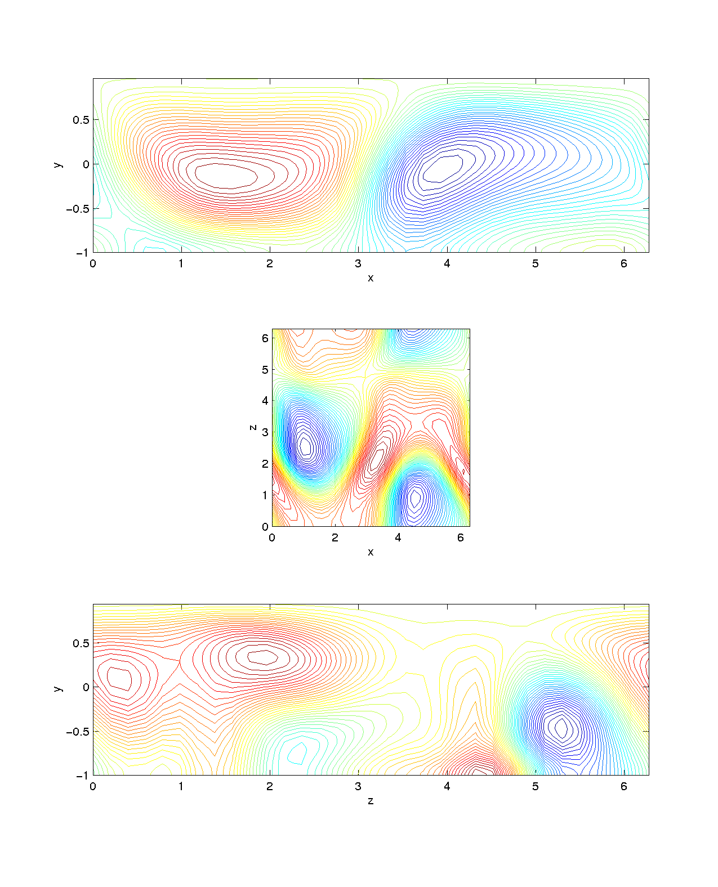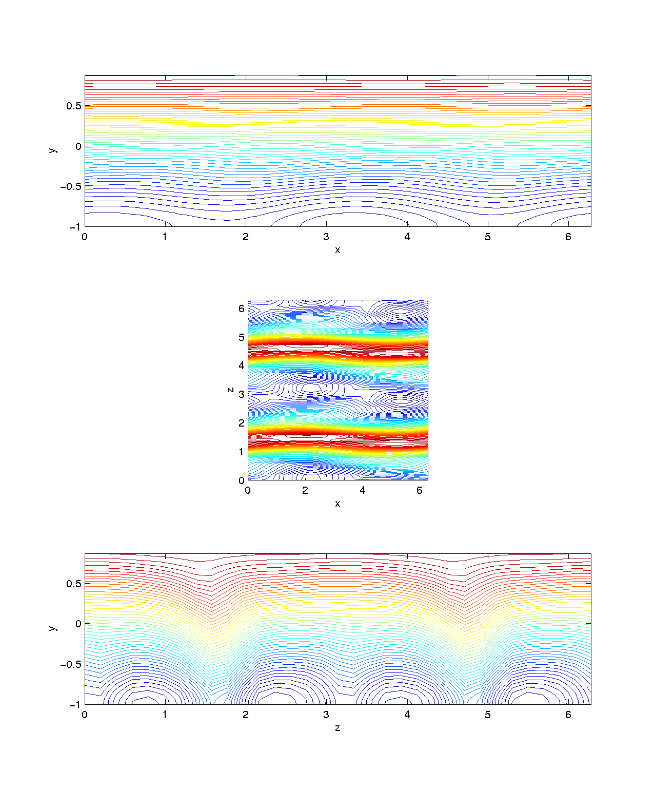

Figure 1. Streamlines at mid-planes for Figure 2. Streamlines at mid-planes for
the horizontal channel case with Ra=20000. 30° inclined channel case with Ra=20000.

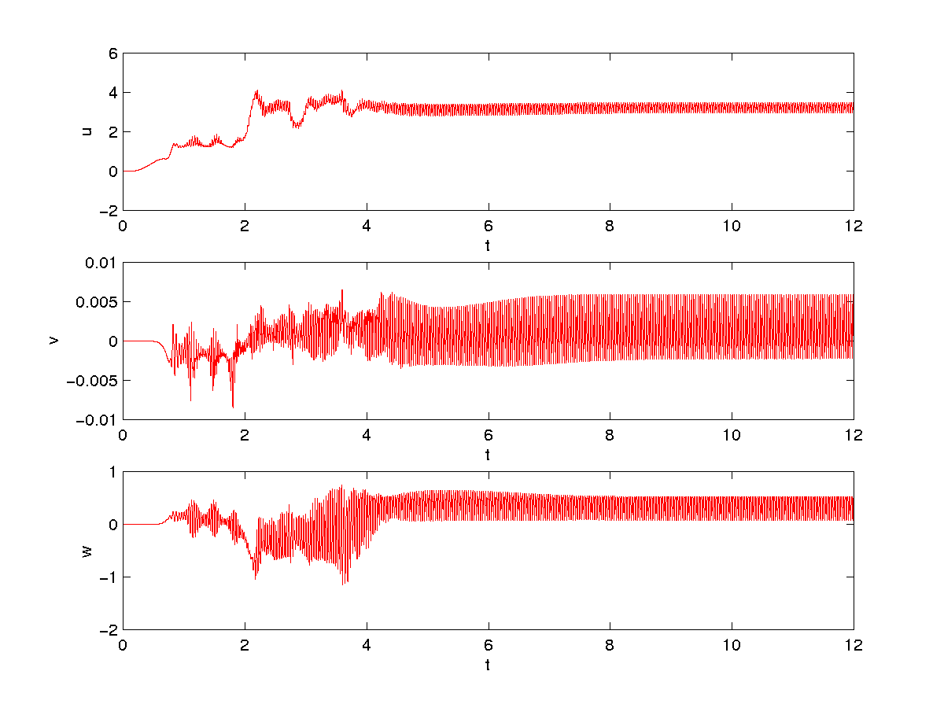
Figure 3. Velocity field components at a corner vs non-dimensional time.

