ANALYSES OF HEAT TRANSFER IN STATIONARY
AND ROTATING RIBBED BLADE COOLING PASSAGES
USING COMPUTATIONAL FLUID DYNAMICS

Robert A. Brewster and Sreenadh Jonnavithula
adapco, 60 Broadhollow Road, Melville, NY 11747 U.S.A.

Computational fluid dynamics predictions of the flow patterns and heat transfer in simplified ribbed-wall blade cooling passages have been performed for representative operating conditions. Analyses have been performed with different mesh densities and using different turbulence models to assess the sensitivity of predicted results to these parameters. Computed local heat transfer results are compared to measurements available in the literature to assess their accuracy.

INTRODUCTION

The increasing need for understanding and improving the cooling of gas turbine blades is well known. As a result, there has been an increasing desire for computational techniques which can accurately predict the heat transfer characteristics of blade cooling passage designs under realistic operating conditions. In this paper, a commercial computational fluid dynamics (CFD) code, STAR-CD¹, is used to analyze geometries having the essential characteristics of common turbine blade cooling passage designs.

Although a number of CFD analyses of representative cooling passage geometries have been performed in recent years²⁻³, the advent of advanced computing technology and parallel processing make calculations on very fine meshes feasible. In addition, continuing developments in the area of turbulence modeling are expected to lead to improvements in the accuracy of predictions. This paper presents results of CFD predictions using very high mesh densities. In addition, results are provided from analyses using several different turbulence models. Comparisons to measurements are used to assess the accuracy of the predictions.

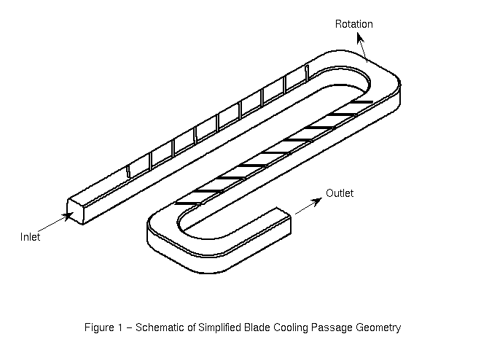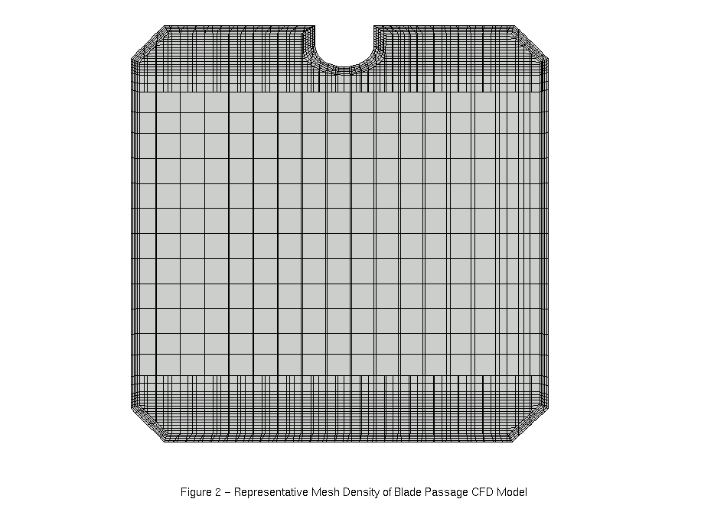
Figure 2 - Representative Mesh Density for Blade Passage CFD Model

Figure 1 - Schematic of Simplified Blade Cooling Passage Geometry (Leading Surface Facing)

TEST CONFIGURATION AND MEASUREMENTS

The geometry analyzed in this paper is shown in Figure 1. This geometry represents a portion of a geometry which had previously been investigated experimentally⁴, and for which heat transfer coefficient data on the leading, trailing and lateral surfaces area available for both stationary and rotating conditions. The geometry has ribs skewed at a 45° angle and staggered on the leading and trailing surfaces. The lateral surfaces are smooth.

In the experiments⁴, all walls of the channels were heated to a constant temperature, except for the inner surfaces of the bends, which were insulated. Steady-state heat flow and fluid temperature measurements were made over various portions of the geometry. These heat transfer coefficients form the basis for comparison with the CFD analyses.

CFD ANALYSES

All numerical analyses were performed using the STAR-CD commercial CFD software package¹. STAR-CD solves the steady or transient fully compressible and viscous mass, momentum and energy conservation equations on unstructured meshes. Analyses may be performed in serial (one processor) or parallel (multi-processor) mode. For the calculations described in this paper, a bounded, gradient-based TVD scheme called MARS⁴ was used for the spatial differencing of the convective terms.

The computational models were constructed using the samm⁵ (semi-automatic meshing methodology) software package. samm employs “trimmed cell technology” to produce a high quality mesh which consists primarily of hexahedral cells and some polyhedral cells.

Figure 2 shows one of the meshes used in the present study. This ribbed wall model consists of approximately 2.74 million cells, including 10 near-wall extruded cell layers. Special effort was made to refine the mesh behind the ribs, in order to capture the details of wakes behind the ribs. The very dense near-wall mesh was also required to accommodate the requirements of the two-layer wall turbulence model, as described below.

Turbulence in the flow was modeled using the Reynolds time averaging procedure. For the results presented here, the RNG (Re-Normalization Group) variant of the k-ε model was used. In conjunction with the RNG model, a two-layer model was used to model the turbulence in the boundary layer. In this approach, a one-equation algebraic model was used to compute the turbulence dissipation (ε) within the boundary layer. In addition to the RNG model, other turbulence models have been investigated and results will be part of the final paper.

The working fluid for the analyses was air. The inlet boundary conditions correspond to a Reynolds number of approximately 25,000. For the rotating cases, the rotational speed was 550 rpm about an axis lying in the plane of the cooling passage and located 21.6 inches upstream of and parallel to the inlet plane. The analyses were performed in parallel on four IBM SP2 200 MHz processors.

RESULTS AND DISCUSSION

Representative results of the calculations are shown in Figures 3 and 4. Figure 3 shows a comparison between the computed and measured normalized Nusselt numbers on the leading and trailing surfaces at a rotational speed of 550 rpm as a function of the normalized streamwise coordinate. The results in Figure 3 show good agreement with the measurements in most respects. The trends are generally predicted correctly (the exception being the last data point on the leading surface), although the CFD predictions consistently underpredict the magnitudes of the heat transfer coefficients.

Figure 4 shows the secondary flow generated by the combined effects of the skewed ribs and the rotational effects. In the absence of the ribs, the flow would be symmetric about the vertical centerline. However, this symmetry is destroyed by the skewed ribs which direct the flow toward the outer (left) wall.

Figure 3 - Comparison of Measured and Predicted Normalized Nusselt Numbers for Rotaing Conditions
X / D_{h}
Nu/Nu∞
Nu/Nu∞
Figure 4 - Secondary Flow Midway Along the First Ribbed Leg
Under Rotating Conditions (View from Upstream)

REFERENCES

1. STAR-CD V3.10 Methodology and User Manuals, Computational Dynamics, London, UK, 1999.
2. Bonhoff, B., Tomm, U., and Johnson, B.V., Heat Transfer Predictions for U-Shaped Coolant Channels with Skewed Ribs and with Smooth Walls, ASME 96-TA-007, ASME Turbo Asia, Jakarta, Indonesia, November 5-7, 1996.
3. Bonhoff, B., Tomm, U., Johnson, B.V. and Jennions, I., Heat Transfer Predictions for Rotating U-Shaped Coolant Channels with Skewed Ribs and with Smooth Walls, ASME 97-GT-162, International Gas Turbine & Aeroengine Congress & Exhibition, Orlando, Florida, USA, June 2-5, 1997.
4. Johnson, B.V., Wagner, J.H., Steuber, G.D. and Yeh, F.C., Heat Transfer in Rotating Serpentine Passages with Trips Skewed to the Flow, ASME J. Turbomachinery, Vol. 116, pp. 113-123, 1994.
5. The samm v2.02.01 User Manual, adapco Software, Melville, NY, USA, 1999.

