CHARACTERISTICS OF HEAT TRANSFER ON THE HIGH PERFORMANCE
CERAMIC HEAT EXCHANGER

Katsuo Asato, Masaya Kumada and Takasi Yamamoto
Department of Mechanical & Systems Engineering, Gifu University
1-1 Yanagido, Gifu 501-1193, Japan

ABSTRACT
A ceramic heat exchanger using a fluidized bed for high temperature gas was developed for the coal-fired gas turbine combined cycle¹. Smooth and finned ceramic tubes were used for heat transfer tubes. It was certified that the heat transfer coefficient on the outside wall of the tube was sharply increased by using a fluidized bed and the finned heat transfer tubes. But, the overall coefficient of heat transmission became dominant by the heat transfer inside the tube. Therefore, heat transfer enhancement on the inside wall of the tube is needed. It was supposed relaminalization occurred at heating rates. Experiments were performed inserting twist tapes into the inside of the tube and heat transfer coefficient on the inside wall of the tube at high heating rate was evaluated.

EXPERIMENTAL APPARATUS
Figure 1 shows finned ceramic heat transfer tubes (silicon nitride) for evaluating the performance of heat exchanger. The heat transfer tube had six ribs for heat transfer enhancement on the inside wall of the tube. Figure 2 shows the apparatus for measuring the heat transfer coefficient on the inside wall of a tube. Air was supplied to the horizontal heat transfer tube which was heated by the heater. The maximum tube wall temperature in these experiments was about 880K. Figure 3 shows the shape of twist tape used in this study. Tape was made of stainless steel and a 1 mm thickness. This tape was inserted the heat transfer tube which was made of stainless steel and had a 8.0mm out diameter, 6.0mm inner diameter and 600mm length.

TYPICAL RESULTS
Figure 4 shows the variation of the local Nusselt number on the inside wall of the tube with Reynolds number in the case of a round tube. The lines on the figure show the Nusselt number of fully developed laminar flow and turbulent flow in a round tube on condition of constant heat flux. On condition of large inlet Reynolds number, the Nusselt number was in proportion to about 0.8 power of the Reynolds number. But, the drop of the Nusselt number along the air flow direction was large on condition of Rew=4600. This figure suggests occurring relaminalization.
Figure 5 shows the variation of the local Nusselt number on the inside wall of the tube with the Reynolds number in the case of the fan-shaped tube. The lines on the figure show the Nusselt number of fully developed laminar flow in a round and triangular tubes and turbulent flow in a round tube on condition of constant heat flux. The local Nusselt number was much influenced with the Reynolds number (in proportion to more than 0.8 power of Reim) even in the case of large inlet Reynolds number. The degree of relaminalization in the case of the finned tube was larger than in the case of the smooth tube. This suggests that relaminalization occurs easier in the fan-shaped tube than in the round tube.

CONCLUSIONS
- It was confirmed that relaminalization occurred at high temperature.
- Relaminalization occurred if the heat flux parameter was larger than a certain value in the round tube.
- The relaminalization limits did not appear clearly in the case of the fan-shaped tube. This was due to coexistence of laminar and turbulent flows.
- The heat transfer coefficient was improved by applying twist tapes. There is possibility of realization of inhabit an effect of relaminalization.

REFERENCE
1. Kumada, M., A study of the high performance ceramic heat exchanger for ultra high temperatures, Heat Transfer Enhancement of Heat exchanger, Edited by S. Kakac, et al, Kluwer Academic Publishers, NATO ASI Series, Series E, Vol.355, pp301-324, 1998. .
- Blower
- Flow Meter
- Heat Transfer Tube
- Mixing Chamber
Figure 1 Ceramic finned tube Figure 2 Experimental apparatus
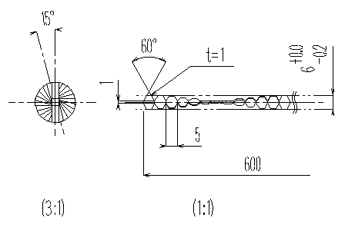
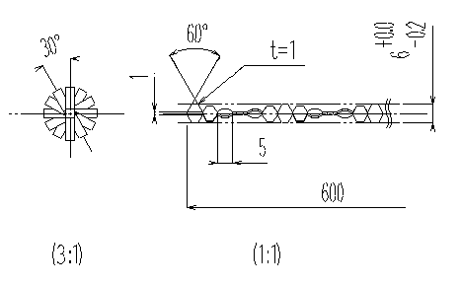
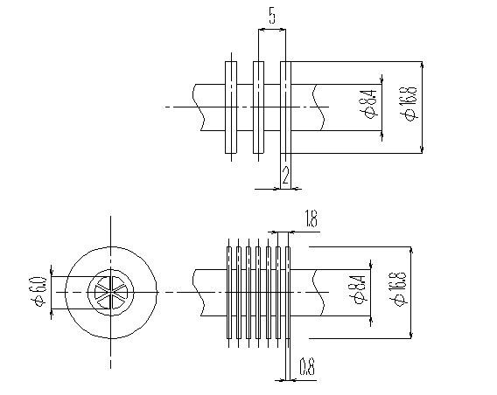
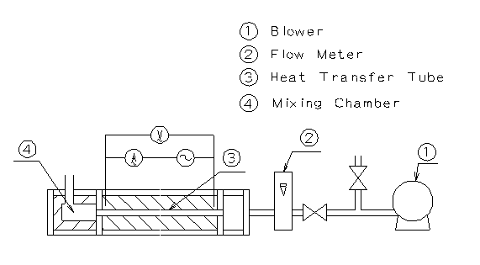
Figure 3 Twist tape

Figure 5 Variation of local Nusselt number on the inside wall of the tube with the Reynolds number
Figure 4 Variation of local Nusselt number
on the inside wall of the tube with the Reynolds number

