Interfacial Behavior of Growing Bubbles in Bead-packed Structure

Z. Wang and X. F. Peng

Department of Thermal Engineering, Tsinghua University, Beijing 100084, China

J.M. Ochterbeck

Mechanical Engineering Department, Clemson University, SC 29634, USA

Introduction
A visual study was conducted on the boiling behaviors, especially the microscale liquid flow around bubbles associated with the evaporation and condensation at bubble interface in a three-dimensional porous structure made of staggered glass beads. The bead-packed structure was heated from below and filled with working fluids. Using a high-speed video imaging system, pore-scale bubble dynamical behavior was observed.
Under the condition of subcooling, a unique characteristic, Replenishment driven by the evaporation and condensation taking place at the bubble interface, was observed. Replenishment was the main liquid-supply for the evaporation at the bottom of the bubble interface. As the applied heat flux changed, the bubble interface adjacent to the bridge-channel zone that connects two neighboring distorted bubbles moved while the balance between the interfacial evaporation flux and the replenishment flux was broken.
Interfacial mass transfer mechanisms played an essential role to the liquid flow around bubbles and the high heat transfer efficiency noted for nucleate boiling. There existed a zone around the bubble surface that exhibited zero net mass flux, termed herein as the “zero-flux zone”. The zero-flux zone shifted to the top of bubble with increasing the heat flux. As the zero-flux zone surpass the concave portion of the distorted bubble, the replenishment was weakened and the dry-spot was enlarged. A theoretical analysis was performed to describe the replenishment and the associated interfacial mass transfer. The theoretical results were compared with the experimental observation, and they are in quite good agreement with each other.
Experimental Observation and Discussions
The experiments were performed using the experimental apparatus shown in Figure 1. In this experiment, a three-dimensional porous structure was made of a number of staggered glass beads which were randomly placed on the substrate of the glass vessel and touched each other without spacing. A heating assembly consisting of a labyrinth-type metal heater and a DC power supply was mounted at the bottom of the vessel.
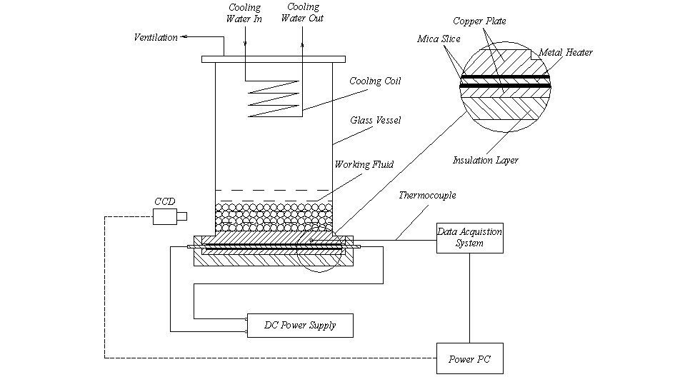
Figure 1 Experimental Apparatus
The CCD camera equipped with a zoom lens was focused on the pore-scale view (see Figure 2) to visualize the bubble behavior at the pore level of the bead-packed structure.
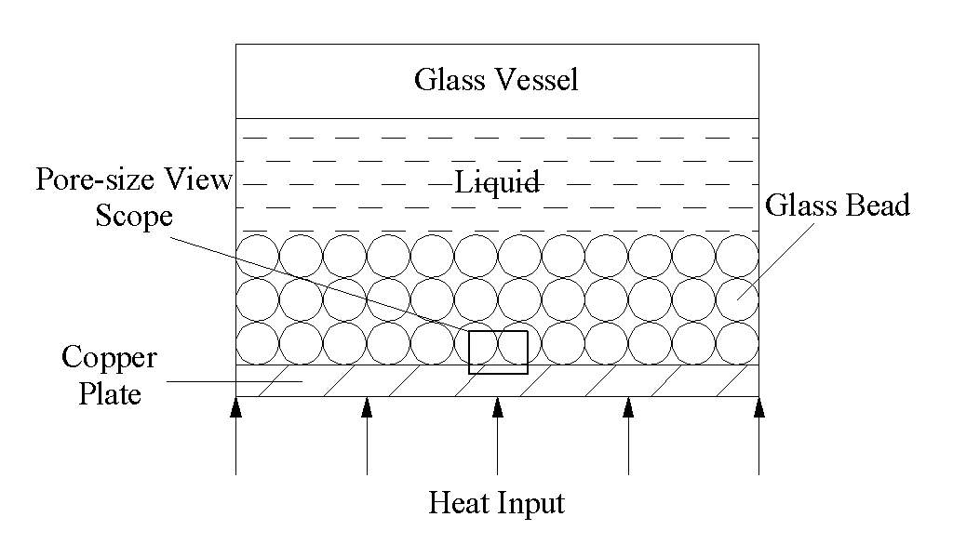
Figure 2 Pore-scale view scope of the CCD camera
The experiments were performed at atmospheric pressure by increasing the heat flux from 16.1 kW/m² to 121.3 kW/m². For subcooling liquids, pore-scale bubble behavior was observed.
In the pore-scale view, it was observed that the bubble distorted and elongated for the case when the pore size became the restriction of the bubble’s further growth as the bubble grew. A concave section was shaped in the middle of the distorted bubble (see Figure 3), consequently a downward replenished-liquid flow was driven by the pressure difference that was caused by the special configuration of the distorted bubble. Replenishment in the bead-packed structure is a unique characteristic, and plays a very important role on the dry-out and rewetting process. As the applied heat flux changed (increased or decreased), the liquid-vapor interface adjacent to the bridge-channel zone that connects two neighboring distorted bubbles moved (dry-out or rewetting) while the balance between the interfacial evaporation flux and the replenishment flux was broken.
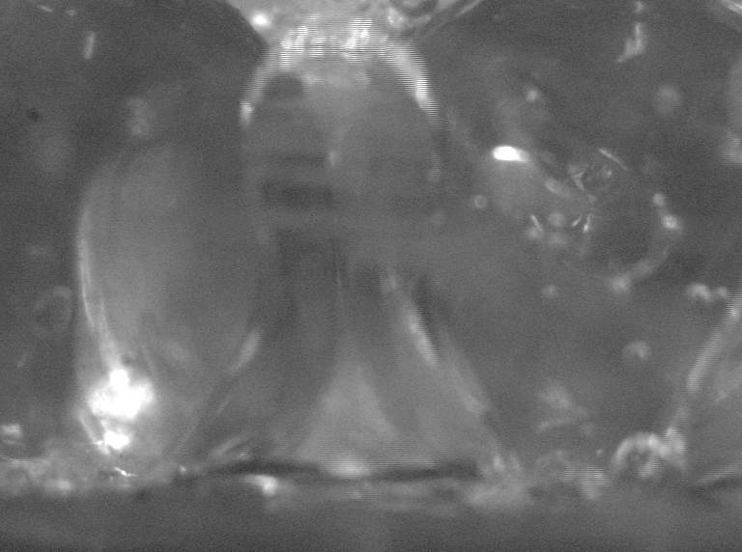
Figure 3 Configuration of distorted bubble

Theoretical Analysis
The microscale liquid flow around the bubble was driven by the evaporation and condensation taking place at the bubble interface, and confined by the pressure difference that was caused by the special configuration of the distorted bubble. Under this pressure difference, the liquid flow was arranged to a well-regulated downward flow, just the replenishment. For a vapor bubble attached to a heating surface, the evaporation mainly occurred at the interface near bubble base while the condensation at the top of the bubble. Between the evaporation regime and the condensation regime, there should exist a portion of bubble surface at a zero mass flux. This portion of bubble surface with a zero mass flux is herein denoted as “zero-flux zone”.
We had explored the influence of the position for the zero-flux zone to replenishment by investigated the mass transfer at the bubble interface. It was found that as the zero-flux zone surpass the concave portion of the distorted bubble with increasing the heat flux, the replenishment was weakened, and consequently the dry-out proceeded.
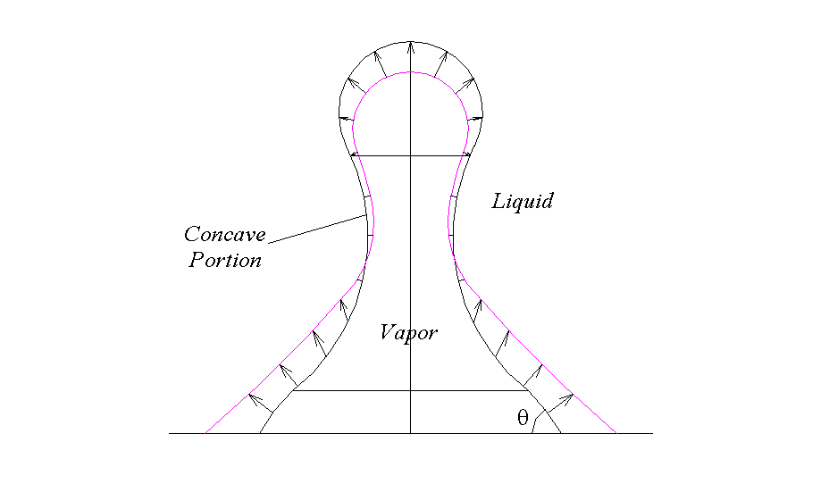
Figure 4 Interfacial mass flux of bubble

References
Z. Wang, X.F. Peng, T. Liu, Visualization of Boiling Phenomena in A Bead-packed Structure, Experimental Heat Transfer, in press.
Q. Liao, T. S. Zhao, A Visual Study of Phase-Change Heat Transfer in A Two-Dimensional Porous Structure with A Partial Heating Boundary, International Journal of Heat and Mass Transfer, vol. 43, pp. 1089-1102, 2000.
T. S. Zhao, Q. Liao, On Capillary-driven Flow and Phase-change Heat Transfer in A Porous Structure Heated by A Finned Surface: Measurements and Modeling, International Journal of Heat and Mass Transfer, vol. 43, pp. 1141-1155, 2000.
Z. M. Li, X. F. Peng, D. J. Lee, T. Liu, Mass Transfer Behavior at Bubble Surface during Nucleate Boiling, Heat and Mass Transfer, in press.
Y. H. Yan, J. M. Ochterbeck, X. F. Peng, Numerical Study of Capillary Rewetting in Porous Media, Proc. 11th IHTC, Kyongju, Korea, vol. 4, pp. 509-514, 1998.

