Micro-Droplet Movement by Programmed Roughness Surface

Cheng-Jung Li, Fan-Chung Tseng, Fan-Gang Tseng, and *Ching-Chang Chieng
Department of Engineering and System Science, National Tsing Hua University, Hsinchu, Taiwan, 30043, Tel: +886-35-716691, Fax: +886-35-720724, email: cchieng@mx.nthu.edu.tw

Introduction
This work explores the phenomenon of a micro-meter-diameter droplet moving on a surface subjected to a programmed roughness profile. Surface roughness increases the drag significantly for macroscale fluid flowing systems, and the effect may be increased as the system gets smaller and the surface properties play more important roles. However, surface tension force is the major force driving the fluid in microscale flow passage and the contact angle representing solid-liquid-gas interface determines the direction of the driving force. Asymmetrically structured surface [1] has been reported as one of means to drive the liquid. Present study derives a simplified mathematical model to illustrate the movement of a micro-droplet driving by the programmed roughness profile without any other forces.

Mathematical Formulation
The rough surface is modeled as a periodic cosine function and the droplet is maintained as a part of the sphere with a fixed contact angleθ as shown in Fig.1. As the droplet moves along the wavy surface, the directions of the surface tension varies with the roughness profile although the contact angle remains the same, i.e. the receding and advancing angle of the forces acting on the droplet are different. The force balance on the droplet can be calculated as
ma = mg sinψ+γw cos(θ+ψ-α₂) -γw cos(θ+α₁-ψ) – F_{r} (1)
where a , m, g, and F_{r} are the acceleration, mass of the droplet, gravity, and friction force, respectively.
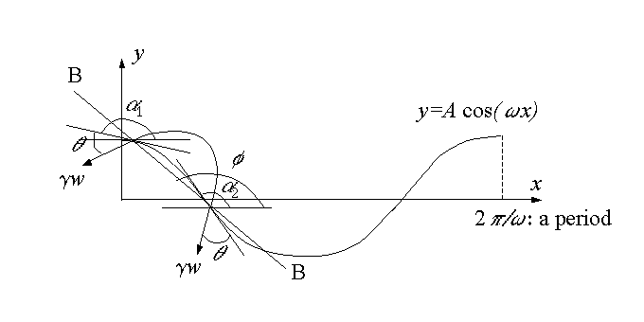
Figure 1 Schematic Diagram of a Droplet on a Cosine-wave Surface.

Preliminary Results and Discussion
In the first phase, the friction force is neglected for simplification but will be integrated in the future work. The equation of the cosine-wave surface is y=A cos(ωx), where roughness height A=5μm is used, and ω is its period in m⁻¹. Figure 2 compares the moving accelerations for different drop sizes if θ=86 (deg). The smaller the droplet size is, the surface tension is more important and higher the acceleration peaks are. The figure also indicates a transition from positive to negative acceleration at the lowest valley (i.e., x=π/ω). Figure 3 shows the variation of accelerations of the droplets with various contact angles, but the same volume. The phenomena makes the possibility to move the droplet up and down by the controlling the roughness shape and contact angles without supplying any additional energy to the system.
The success of implement the above idea is demonstrated in Fig. 4, two cases with different waviness periods are considered: (1) Case #1 with solid surface profile as single cosine function, i.e. y=A cos(ωx) and ω=10⁶ (m⁻¹) and (2) Case #2 with two different cosine functions , i.e. y=A cos(ω₁x) for uphill and y=A cos(ω₂x) for downhill, ω₁=2x10⁶ (m⁻¹) and ω₂=10⁶ (m⁻¹) for up, as shown in Fig. 4(a). From Fig. 4(b), it is shown that the locations of the acceleration peaks along the x axis for Case #2 are regulated as compared with those for Case #1. By integrating the acceleration twice along the curvature (i.e., along ds², where ds²= dx²+ dy²), the droplet displacements vs. time is obtained (Figure 3c), which implying that the velocity is always positive. Thus, the drop in Case #2 can move by itself along the surface. The above analysis gives the promise that the drop can move on a surface with programmed profile. The second phase work (in full paper) would include the friction term in analytical solutions to prove the concept in total.

Reference
[1] O. Ssandre, L. Gorr-Talini, A. Ajdari, J. Prost, and P. Silberzan, “Moving Droplets on Asymmetrically Structured Surfaces”, Physical Review E, Vol. 60, No.3, p2964-2972, September, 1999
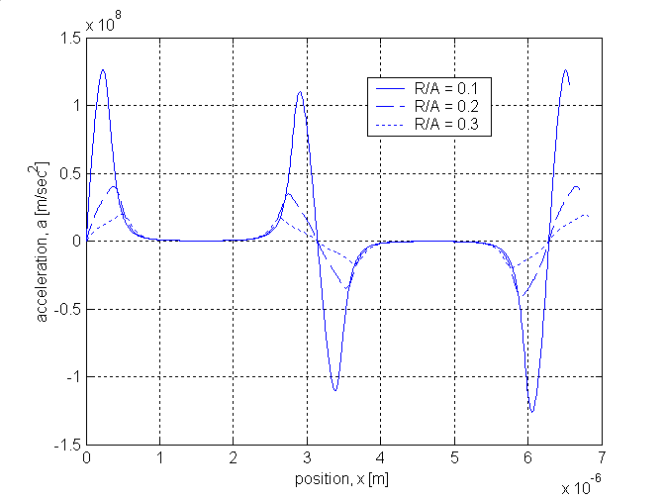
Figure 2 The drop acceleration with θ=86∘and ω=10⁶ (m⁻¹) for different drop sizes.

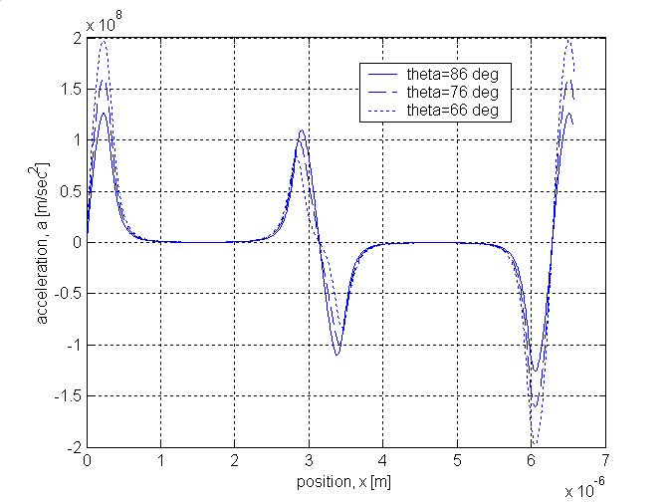
Figure 3 The drop acceleration of various contact angles or solid surfaces for a drop with a constant volume and ω=10⁶ (m⁻¹) (R=0.5x10⁻⁶ for the θ=86∘case).

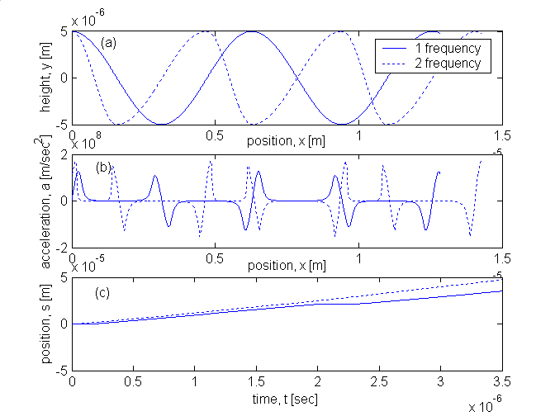
Figure 4 Comparison of two cases (the surface waviness of case #1 and #2 are composed of one and two different frequencies, respectively), with θ=86∘and R=0.5x10⁻⁶ (m): (a) y vs. x; (b) a vs. x; and (c) displacements vs. time t.

