MICRO-DROPLET MOVEMENT BY PROGRAMMED WAVY SURFACE

Chen-Jung Li*, Fan-Chung Tseng, Fan-Gang Tseng**

Shih-Lin Chang*, and C.C. Chieng**
* Department of Physics/ ** Engineering and System Science
National Tsing Hua University, Hsinchu, Taiwan, 30043

INTRODUCTION
The movement of a micro-scale droplet is of interest for applications in microfluidic systems and MEMS devices. Surface tension force is the dominant force for micro-scale droplets and can be manipulated through the interfacial tension gradients¹ or surface energy variation due to the change of contact angles by asymmetrically structured surface². This work explores the possibility to move a micro-meter-diameter droplet, via manipulating the surface tension, on a programmed asymmetrical cosine-wave surface without any external forces. An analysis model is derived to calculate the droplet’s moving trajectory with wetting effect neglected or considered.

MATHEMATICAL FORMULATION
The formulation is based on the extension of Furmidge³ model for the droplet motion along a cosine wavy surface y=A cos(ωx), where A is the waviness height and ω is its period in m⁻¹, as shown in Fig.1. The assumptions are made to pinpoint the concept in steps: (1) droplet is considered as a whole body with same velocities inside the droplet, and (2) friction force F_{r} due to the droplet moving is neglected. The force balance between gravity, surface tensions, and friction force, can be formulated as
ma = mg sinψ+γw cos(θ_{a}+ψ-α₂) -γw cos(θ_{r}+α₁-ψ) – F_{r} (1)
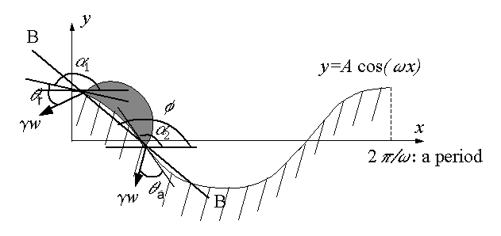
Figure 1 A drop on a cosine-wave surface.
where a , m, g, γ, w, θ_{a}, θ_{r}, ψ, α₂, and α₁are the acceleration, mass of the droplet, gravity, the surface tension, the droplet width along the direction perpendicular to the xy plane, the advancing and receding contact angles, the slope of the line connecting the leading and receding contact points, the surface slopes at the leading and receding contact points, respectively.

RESULTS AND DISCUSSION
(I) Receding and advancing angles are the same:
Three arrangements of the wall surface profiles with different waviness periods alter the locations and magnitudes of the acceleration peaks and dips along the x-axis (Fig. 2b), thus the droplet moving speeds. Fig. 2(c) shows that the velocity of the Case #2 droplet (dash line) is lifted higher than Case #1(solid line) and it implies that a faster downhill wall plus a slower uphill slope (like Case #2) is a better design to drive the micro-droplet. It is also interesting to see that Case #3 (dotted line) with a slower downhill plus a faster uphill wall yields the slowest droplet velocity and the negative velocity before arriving the top of the uphill even implies the backward movement. Apparently, the droplet of Case #2 would eventually move faster and farther than the case of a droplet moving along a flat surface. The above analysis gives the promise that the drop can move on a surface with a programmed surface profile.
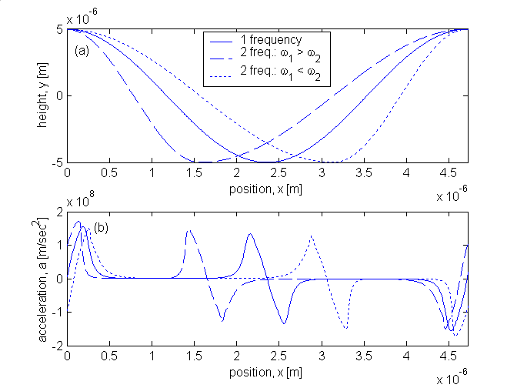 | 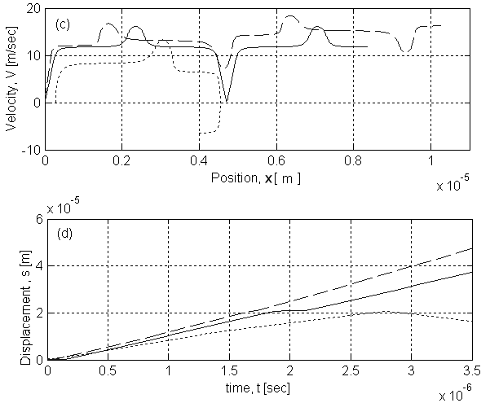
Figure 2 Comparison of three cases (Cases #1, #2, and #3 have one, two (ω₁>ω₂), and two (ω₁<ω₂) wavy periods, respectively), with θ=86∘, R=0.5 (μm), A=5 (μm): (a) y vs. x; (b) a vs. x; (c) velocity vs. position x, and (d) displacement s vs. time t.

(II) Receding and advancing angles are different, θ_{a} >θ_{r}
The difference of these angles is assumed as 5 degree in the demonstration case. That is, the trailing surface is more hydrophilic due to wetting and the deceleration of the droplet is resulted. Fig. 3 plots the maximum distance along (a) s and (b) x that the droplets with various diameters d can move at different initial velocities. Fig. 3(a) indicates that (1) the sliding ranges along the curvature s are almost the same for these droplets (but only 2d) with initial velocities less than 5 m/s, and (2) the sliding range increases up to 8d for the 2-μm droplet with the 10 m/s initial velocity. Fig. 3(b) shows the sliding distance in x-axis instead of s-axis and indicates that the droplets actually travel to very short distances (1.7 d for 2μm-sized droplet with 10 m/s initial velocity) due to the very high hill of the wavy surface (A=5 μm). Furthermore, the droplets for most cases/points in Fig. 3 stop after moving a certain distance, and some droplets travel back and forth around the valley of the cosine wave. Results are also obtained for a droplet moving on a cosine surface with a different amplitude A=2.5. It shows that for most cases the same sized droplet travels a longer distance on a flatter wavy wall.
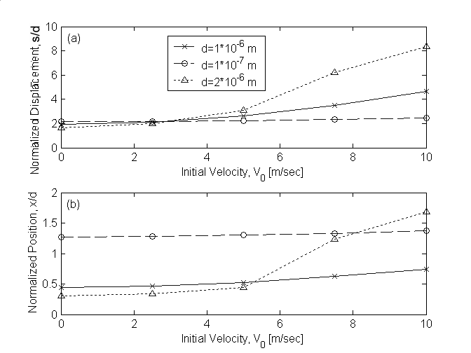
Figure 3 (a) s/d (b) x/d vs. initial velocity (A=5*10⁻⁶ m)

In conclusion, the analytical solutions show that the droplet does move continuously, even with its velocity increased after each full period/cycle on a fast-downhill and slow-uphill wavy surface, if the wetting effect is not considered. However, when the wetting effect is considered, droplets of selected sizes and initial velocities will only move to a certain distance with or without back-and-forth traveling. The computations suggest that proper selections of droplet sizes, initial velocities, and the surface profiles would move the droplet farther without any external forces.

REFERENCES
1. S. Daniel, M. K. Chaudhury, J. C. Chen, “Fast Drop Movements Resulting From The Phase Change On A Gradient Surface”, Science, Vol. 291 (26), p. 633-636, 2001.
2. O. Ssandre, L. Gorr-Talini, A. Ajdari, J. Prost, and P. Silberzan, “Moving Droplets On Asymmetrically Structured Surfaces,” Physical Review E, Vol. 60, No.3, p. 2964-2972, September, 1999.
3. C. G. L. Furmidge, “Studies At Phase Interfaces I. The Sliding Of Liquid Drops On Solid Surfaces And A Theory For Spray Retention,” Journal of Colloid Science, Vol. 17, p. 309-324, 1962.

