Interfacial Behavior of Growing Bubbles in Bead-packed Structure

Z. Wang and X. F. Peng

Department of Thermal Engineering, Tsinghua University, Beijing 100084, China

J.M. Ochterbeck

Mechanical Engineering Department, Clemson University, SC 29634, USA

Abstract
A visual experiment was conducted to observe the boiling behavior, especially the micro-scale liquid flow around bubbles associated with the evaporation and condensation at bubble interface in a three-dimensional porous structure made of staggered glass beads. Using a high-speed video imaging system, pore-scale bubble dynamical behavior in the bead-packed structure was investigated. Fundamental characteristics of boiling heat transfer in the bead-packed structure were discussed experimentally.

Keywords: Interface, Bubble Dynamics, Boiling, Bead-packed Structure

Introduction
Much work was done for fluid flow and heat transfer, especially transport processes involving phase-change in porous structures in last two decades, owing to their important technological applications^{[1-2]}. In recent years, experimental investigations of boiling heat transfer in porous structures were performed associated with the development of the porous-wicked evaporator for CPL (Capillary Pumped Loops) system^{[3-6]}.
The porous-wicked evaporator, as the most important component, represents the heart of a CPL system and correspondingly determines the available capillary pumping head for heat transport of the overall loop^{[7]}. Depriming and dry-out of the capillary structure due to excess heat addition or system transients can readily defunct the evaporator or the entire system without following a rewetting of porous structure^{[3]}. These issues are still open for understanding and need to be solved in practical technological applications urgently. Knowledge of special interfacial phenomena induced by important geometrical configurations in porous structure was needed to describe some mechanisms associated with basic boiling characteristics and improve the performance of evaporator pump^{[2,8]}.
In this paper, a visual experiment was conducted to investigate boiling heat transfer in a three-dimensional porous structure consisting of staggered glass beads. The present research was focused on exploring the pore-scale interfacial behavior of growing bubbles, and providing experimental evidence and reference for the establishment of theoretical model. A qualitative analysis was also performed trying to describe some special boiling characteristics in the bead-packed structure.

Experimental Investigation
The experiments were performed using the experimental apparatus shown in Figure 1. In this experiment, a three-dimensional porous structure was made of a number of staggered glass beads which were randomly placed on the substrate of the glass vessel and touched each other without spacing. The glass vessel was filled with water. A heating assembly consisting of a labyrinth-type metal heater and a DC power supply was mounted at the bottom of the vessel. The CCD camera equipped with a zoom lens was focused on the pore-scale view (see Figure 2) to visualize the bubble behavior at the pore level of the bead-packed structure. The experiments were performed by increasing the heat flux from 16.1 KW/m² to 121.3 KW/m². The photographic results captured under the different conditions of applied heat flux had been presented by Wang et al^{[9]}.
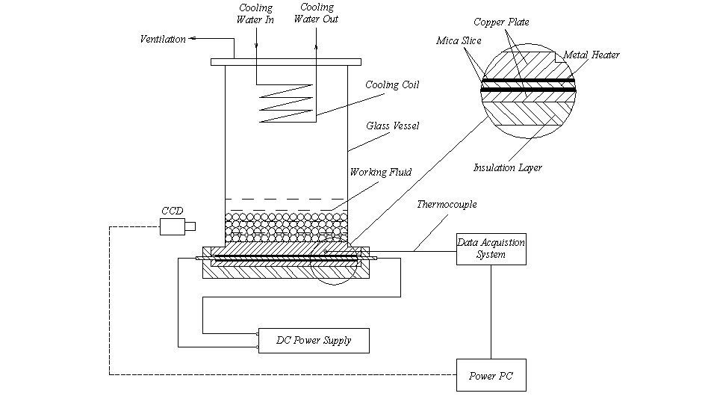
Figure 1 Experimental Apparatus
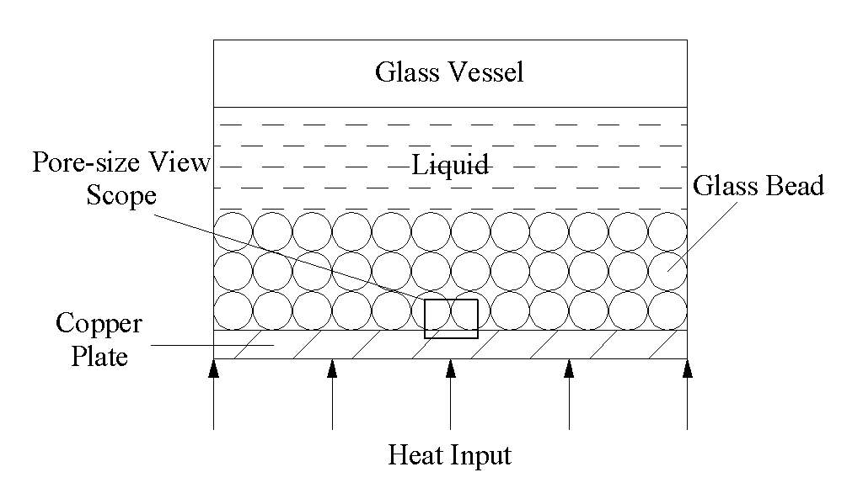
Figure 2 Pore-scale view scope of the CCD camera

Boiling Characteristics and Descriptions

Distorted Bubble Interface
The cavity surrounded by neighboring particles provided a space for bubble growing, but this space was limited and would restrict the bubble further growing as the bubble size increased, so the bubble interface had to be distorted to fit the porous structure.
In the pore-scale view, it was observed that the bubble distorted and elongated for the case when the pore size became restriction on bubble growing. A concave section was shaped at the middle part of the growing bubble (see Figure 3) because the cavity was a shrinking-enlarging shape. Consequently a downward replenished-liquid flow was driven by the pressure difference induced by the special configuration of the distorted bubble. It was the supply for the interfacial evaporation near the bottom of bubble, and also wetted the heating surface. By the action of buoyancy, the concave section slimed down as the bubble elongated gradually. Subsequently the bubble would be truncated at the neck of the elongated bubble and quickly escaped from the cavity. Obviously, this process was propitious to the bubble release.

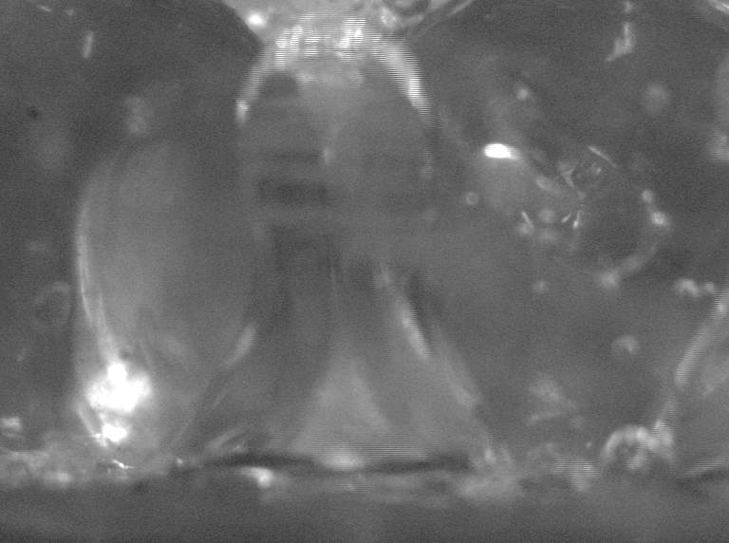
Figure 3 Distorted bubble interface

In conclusion, Influenced by the special geometrical factors, the bubble will change to fit the environment. Also this change must be favorable for the bubble growth.

Replenishment
For the boiling in bead-packed structure, a downward replenishing-liquid flow was observed as a sequence of the bubble shape or structure. This micro-scale liquid flow around the bubble was produced by the evaporation and condensation taking place at the bubble interface, and driven by the pressure difference that was caused by the special configuration of the distorted bubble. The liquid flow was arranged to a well-regulated downward flow, just the replenishment.

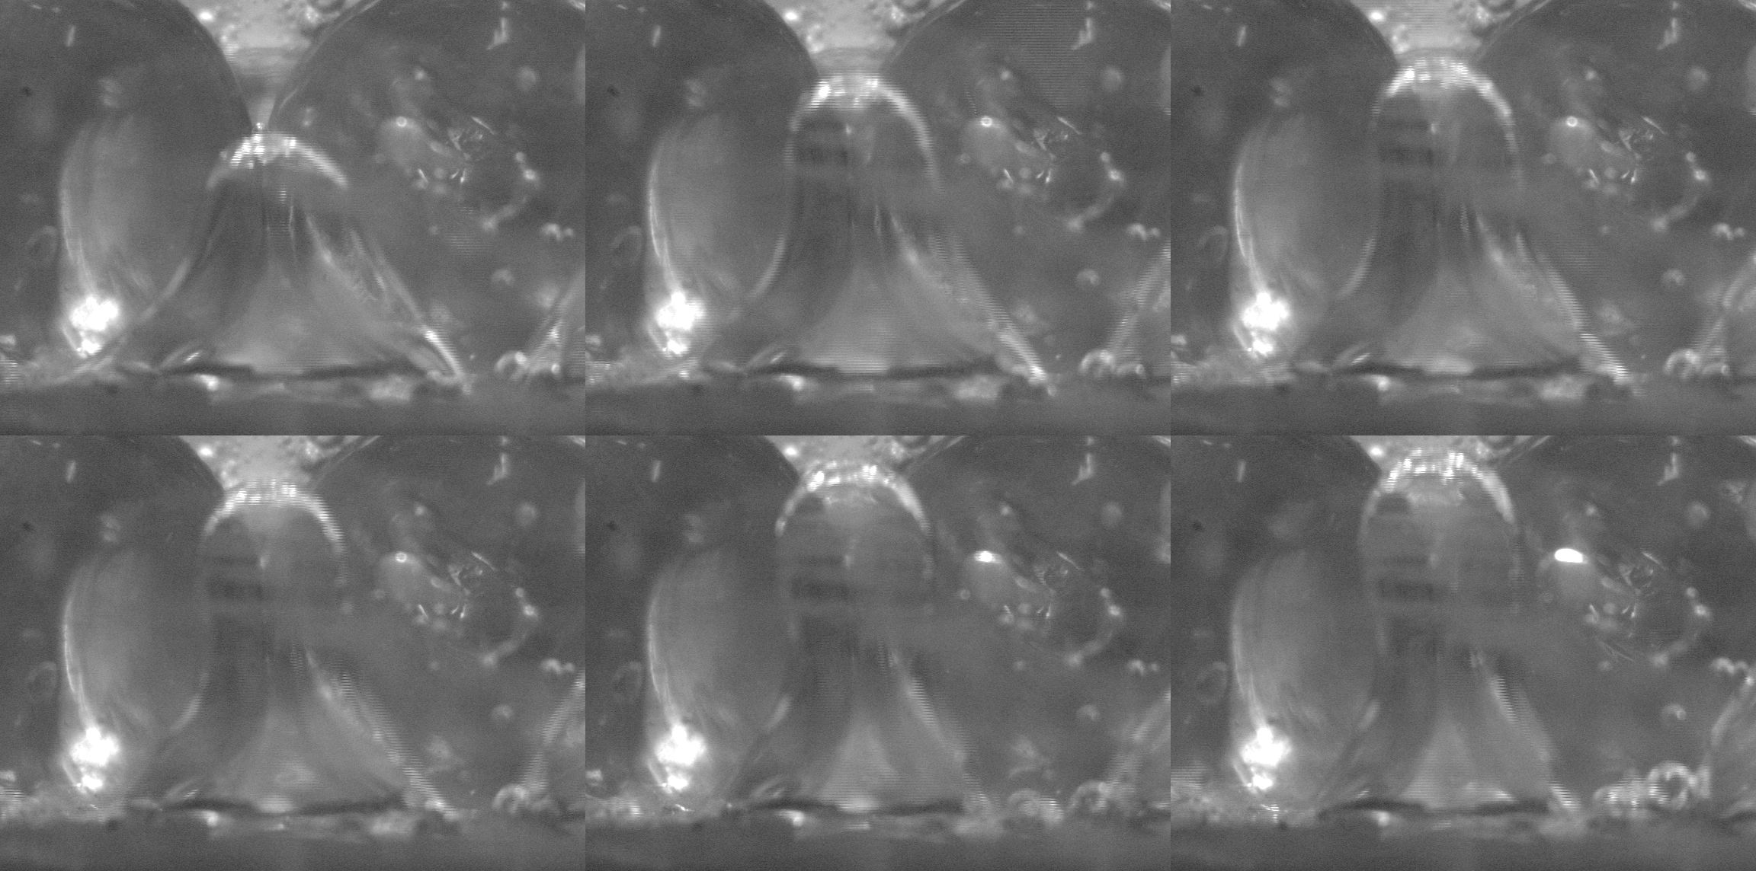
Figure 4 Recoil of bubble interface caused by replenishment

Replenishment in the bead-packed structure is a unique characteristic, and plays a very important role on the dry-out and rewetting process. The replenishing velocity, U_{r}, is related with the pressure difference, $ΔP$, caused by the special configuration of the distorted bubble, expressed as
$U_{r}=\sqrt{\frac{2ΔP}{ρ_{l}}}$ （1）
It is assumed that the pressure, P_{g}, is uniform inside the bubble, and the pressure of the liquid around the lower section of the bubble interface（the configuration of lower section of the bubble interface is close to a part of sphere）, P_{l2} , is deduced as
$P_{l2}=P_{g}−\frac{2σ}{R_{2}}$ （2）
while the pressure of the liquid around the concave section of the bubble interface, P_{l1} , can be written as
$P_{l1}=P_{g}+σ\left(\frac{1}{R_{\text{11}}}−\frac{1}{R_{\text{12}}}\right)$ （3）
$ΔP$ is the difference between P_{l1} and P_{l2}
$ΔP=P_{l1}−P_{l2}=σ\left(\frac{1}{R_{\text{11}}}−\frac{1}{R_{\text{12}}}+\frac{2}{R_{2}}\right)$ （4）
R₁₁, R₁₂ and R₂ are the radius of the concave section and lower section, respectively (see Figure 5). Substituting the pressure difference , $ΔP$, of Eq. (4) into Eq. (1) yields
$U_{r}=\sqrt{\frac{σ}{ρ_{l}}\left(\frac{1}{R_{\text{11}}}−\frac{1}{R_{\text{12}}}+\frac{2}{R_{2}}\right)}$ （5）
It is assumed that R₁₁ and R₁₂ which can be given from the photographic results are invariable as the liquid-vapor interface moved. But R₂ changs during the dry-out and rewetting process, and by the geometry relation, R₂ can be given as
$R_{2}=h\left(\frac{1}{1−\text{cos}θ}+\frac{r_{h}^{2}}{2h^{2}}\right)$ （6）
Substituting Eq. (6) into Eq. (5) yields
$U_{r}=\sqrt{\frac{σ}{ρ_{l}}\left(\frac{1}{R_{\text{11}}}−\frac{1}{R_{\text{12}}}+\frac{2}{h\left(\frac{1}{1−\text{cos}θ}+\frac{r_{h}^{2}}{2h^{2}}\right)}\right)}$ （7）

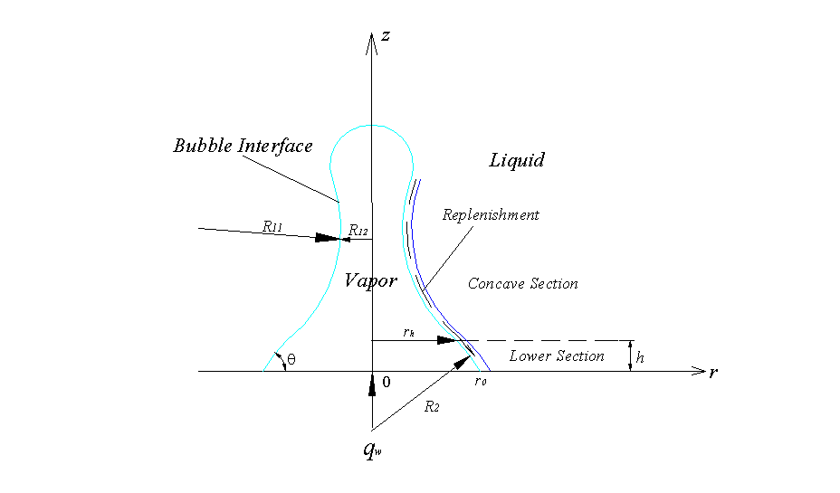
Figure 5 Configuration of bubble interface

Apparently, the replenishment flux is only dependent upon the geometrical parameters for a specified working fluid. If the applied heat flux changes (increases or decreases), the balance between the interfacial evaporation flux and the replenishment flux is broken, and the liquid-vapor interface moves at extreme ends (dry-out or rewetting).

Dry-out of Heated Surface
For the purpose of studying the dry-out process of the heated surface, the porous structure is divided into three areas (see Figure 6), the cavity that is occupied by a primary bubble (the primary bubble is a bigger bubble which is merged by other little bubbles), the narrow-gap corner zone between a glass bead and the heated surface, and the bridge-channel connected two neighboring primary bubbles.

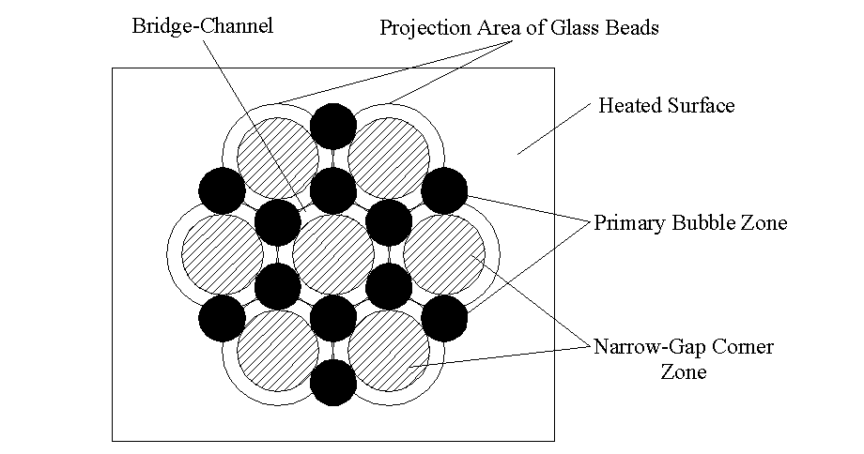
Figure 6 Three zones of bead-packed structure on heated surface

The narrow-gap corner zone is a very open area. As the primary bubble grows, the subcooled replenishing-water is easily pumped into the narrow-gap corner and wets this area. So dry-out on the heating surface is highly difficult to occur due to efficient wetting effect of the narrow-gap corner zone. The wetting effect of the narrow-gap corner is actually dependent upon its liquid supply, replenishment flux. The entryway of the replenishing-liquid should be cut off before the emergence of stable dry-spot on the heating surface.
At a high heat flux, the primary bubbles coalesced immediately once they were generated, and the bridge-channel was occupied by the vapor at most of the time. The energy balance relation at the bubble interface, shown as Figure 5, is derived as
${\overset{˙}{m}}_{e}－{\overset{˙}{m}}_{r}＝ρ_{l}\int{U_{I}⋅2πr\left(z\right)}\text{dz}$ (8)
Eq. (8) means that the liquid-vapor interface moves while the balance between the interfacial evaporation flux and the replenishment flux is broken as the applied heat flux changes. Assuming the applied heat flux from the heated surface is completely the energy of the interfacial evaporation, we have
${\overset{˙}{m}}_{e}＝\frac{q_{w}A_{u}}{h_{\text{fg}}}$ (9)
The dry-out time of the bridge-channel (the time taken by the coalescence of neighboring bubbles) , $τ_{d}^{\text{BC}}$, are related as (the area of bubble base will correspondingly enlarge ${ΔA}_{\text{base}}$)
$\left(\frac{q_{w}A_{u}−h_{\text{fg}}{\overset{˙}{m}}_{r}}{ρ_{l}h_{\text{fg}}}\right)τ_{d}^{\text{BC}}＝\int{U_{I}τ_{d}^{\text{BC}}2πr\left(z\right)\text{dz}}={hΔA}_{\text{base}}$ (10)
or
$τ_{d}^{\text{BC}}＝\frac{ρ_{l}h_{\text{fg}}{hΔA}_{\text{base}}}{q_{w}A_{u}−h_{\text{fg}}{\overset{˙}{m}}_{r}}$ (11)
The dry-out time of the bridge-channel, $τ_{d}^{\text{BC}}$, should be shorter than the minimum time in which neighboring bubbles coexist, $τ_{s}$, because dry-out must be complete before the bubble release. $τ_{s}$ can be determined as
$τ_{s}=τ_{b}−τ_{w}$ （12）
Apparently,
$τ_{d}^{\text{BC}}<τ_{s}$ （13）
The dry-out of bridge-channel is not stable and can be wetted by replenished-liquid very easily. Stable dry-out generally requires that the narrow gap corner is surrounded by the vapor completely. Inspired by a previous work^{[10]}, it is hypothesized that when the number of bubbles surrounding the narrow gap corner zone exceeds a critical number, the feed of liquid is restricted to wet the heating surface, and then an insulating dry-spot of vapor forms on the heating surface. It can be found from the Figure 6 that the narrow gap corner will be encircled by the vapor while the surrounding bubbles exceed six. Therefore it is reasonable to take six as the critical number.
At a high heat flux, it was assumed that the bubble sites on the heating surface are randomly distributed and can be represented by Poisson distribution^{[11]},
$P\left(\text{NA}\right)=\frac{e^{−\bar{N}A}{\left(\bar{N}A\right)}^{\text{NA}}}{\left(\text{NA}\right)!}$ (14)
The probability that the number of bubble site is greater than or equal to the critical number will be found in a unit area (area surrounding a narrow gap corner zone) is
$P\left(n≥6\right)=1−\sum_{n=0}^{5}{P\left(n\right)}$ （15）
Accordingly, the heat flux contributing to nucleate boiling is obtained as
$q_{n}=6q_{b}N\left(1−P\left(n≥6\right)\right)$ （16）
If one ignores single-phase convective heat transfer and influence of film boiling, the heat flux from Eq. (16) can be presumed as overall heat flux. As the surface superheated temperature is raised, more narrow gap corner zones will have a population of surrounding bubble sites over the critical number. Consequently, the number of the insulating dry-spots will increase and the size of dry areas will also increase due to merger of adjacent dry spots. If this trend continues, the CHF occurs.

Conclusions
- Influenced by the geometrical factors, vapor bubbles will change to fit the porous pore structure.
- Replenishment that plays a very important role on the dry-out and rewetting process is a unique characteristic in the bead-packed structure, and also the liquid-supply for wetting effect of the narrow-gap corner zone.
- The condition of dry-out can be expressed as that the dry-out time of the bridge-channel, $τ_{d}^{\text{BC}}$, should satisfy the following relation,
$τ_{d}^{\text{BC}}<τ_{s}$.
- When the number of bubbles surrounding the narrow gap corner zone exceeds a critical number, the feed of liquid is restricted to wet the heating surface.

Acknowledgement
This work is currently supported by funds for Major State Basic Research Projects through the contract No. G2000026301.

References
[1] C.Y. Wang, P. Cheng, Multiphase Flow and Heat Transfer in Porous Madia，in：J.P. Hartnet, T.F. Irvine, Y.I. Cho, G .A. Greene（Eds）, Advances in Heat Transfer, vol . 30, Academic Press, New York, pp. 93-196, 1997.
[2] T. S. Zhao, Q. Liao, On Capillary-driven Flow and Phase-change Heat Transfer in A Porous Structure Heated by A Finned Surface: Measurements and Modeling, International Journal of Heat and Mass Transfer, vol. 43, pp. 1141-1155, 2000.
[3] Jentung Ku, Overview of Capillary Pumped Loop Technology, HTD-Vol.236, Heat Pipes and Capillary Pumped Loops, ASME, 1993.
[4] Jentung Ku, Recent Advances in Capillary Pumped Loop Technology, 1997 National Heat Transfer Conference, Baltimore, MD, August 10-12, 1997.
[5] G. P. Peterson, An Introduction to Heat Pipes: Modeling, Testing and Applications, John Wiley & Sons . Inc. , New York, 1994.
[6] A. Faghri, Heat Pipe Science and Technology, Taylor & Francis, Washington DC, 1995.
[7] Y. H. Yan, J. M. Ochterbeck, X. F. Peng, Numerical Study of Capillary Rewetting in Porous Media, Heat Transfer 98, 11th IHTC, Kyongju, Korea, 1998, vol. 4, 509-514.
[8] Q. Liao, T. S. Zhao, A Visual Study of Phase-Change Heat Transfer in A Two-Dimensional Porous Structure with A Partial Heating Boundary, International Journal of Heat and Mass Transfer, vol. 43, pp. 1089-1102, 2000.
[9] Z. Wang, X.F. Peng, T. Liu, Visualization of Boiling Phenomena in A Bead-packed Structure, Experimental Heat Transfer, in press.
[10] S. J. Ha, H. C. No, A Dry-spot Model of Critical Heat Flux in Pool and Forced Convection Boiling, International Journal of Heat and Mass Transfer, vol. 41, pp. 303-311, 1998.
[11] R. F. Gaertner, C. No, Distribution of Active Sites in the Nucleate Boiling of Liquids, Chemical Engineering Process Symposium Series, vol. 59(41), pp. 52-61, 1963.

Nomenclature
${ΔA}_{\text{base}}$ increment of area of bubble base [m²]
A_{u} area of unit [m²]
h height of lower section [m]
h_{fg} latent heat of liquid-vapor phase-change [KJ/Kg]
m_{e} interface evaporation flux [Kg/s]
m_{r} replenishment flux [Kg/s]
n number of bubble sites
N total number of units
$ΔP$ pressure difference of replenishment [Pa]
P_{g} vapor pressure [Pa]
P_{l1} pressure of the liquid around concave section of the bubble interface [Pa]
P_{l2} pressure of the liquid around lower section of the bubble interface [Pa]
q_{b} heat transferred by single bubble [W/site]
q_{n} heat flux contributing to nucleate boiling [W/m²]
q_{w} applied heat flux [W/m²]
r radius [m]
r_{h} radius of juncture between concave section and lower section [m]
R₁₁, R₁₂ radius of concave section [m]
R₂ radius of lower section [m]
U_{I} velocity of interface [m/s]
U_{r} replenishing velocity [m/s]
z height [m]

Greek Symbols
$ρ_{l}$ density of liquid [Kg/m³]
$σ$ surface tension [N/m]
$θ$ contact angle [degree]
single bubble life time [s]
$τ_{s}$ neighboring bubbles’ minimum coexisting time [s]
$τ_{w}$ waiting time of bubble [s]
$τ_{d}^{\text{BC}}$ dry-out time of bridge-channel [s]

