Title: Micro-Droplet Movement by Programmed Wavy Surface
Short Title: Micro-Droplet Movement by Programmed Waviness

Authors: Cheng-Jung Li¹, Fan-Chung Tseng, Fan-Gang Tseng², Shih-Lin Chang¹, and Ching-Chang Chieng²*
¹: Department of Physics, National Tsing Hua University, Hsinchu, Taiwan, 30043
²: Department of Engineering and System Science, National Tsing Hua University, Hsinchu, Taiwan, 30043
*: To whom correspondence should be addressed, Tel: +886-35-716691, Fax: +886-35-720724, email: cchieng@mx.nthu.edu.tw
Summary
This work explores the possibility for a micro-meter-diameter droplet moving on a surface subjected to a programmed wavy profile without any external forces. Since the surface tension force is the major force driving the fluid in microscale flow passage and the contact angle represents solid-liquid-gas interface and the direction of the driving force, the asymmetrical cosine-wave profile of the wavy surface is considered here to produce an unbalance force to move the droplet. Present study derives an analysis model to investigate the droplet trajectories with the wetting effect neglected or considered. With the wetting effect neglected, the analysis results show that the idea of conversion of free surface energy to kinetic energy is feasible (i.e., the droplet would keep moving forward without stopping) if the wavy surface is design to have a larger downhill period than the uphill one. When the wetting effect is considered, the receding contact angle is less than the advancing contact angle and their difference induces additional drag force impeding or stopping the droplet movement. Proper combinations of programmed droplet sizes and wall surface profiles lead to effective displacement of the droplet.
Introduction
The movement of a micro-scale droplet is of interest in for applications in the microfluidic systems and MEMS devices [1, 2] and there are forces tempted to drive the droplet successfully in micro-scale such as surface tension variation [3,4], electrostatic actuation [5], and asymmetrically structured surface[6]. Surface tension force is the dominant force for micro-scale droplets and can be manipulated through the interfacial tension gradients due to the nonuniformity of temperature, pressure, and surfactant concentration within the fluid interface, i.e. the so-called Marangoni effect [3,4] or surface energy variation due to the change of contact angles by asymmetrically structured surface [6]. Additional force as electrostatic force has been attempted to drive the droplet through an underneath array of electrodes in a micro device [5].
This work explores the phenomenon of a micro-meter-diameter droplet moving on a surface subjected to a programmed wavy profile via a simplified mathematical model without any other external forces. As the droplet moves along the wavy surface, the contact angles representing solid-liquid-gas interface are different at interface lines and the directions of the surface tension forces are varied. Therefore, unbalance forces will move the target droplet.

Mathematical Formulation
Furmidge [7] studied the retention of a droplet on a tilted surface using the force equilibrium of the droplet weight and surface tensions with zero acceleration. The formulation is extended here to investigate the droplet motion along a wavy surface. The wavy surface is modeled as a periodic cosine function and the droplet is maintained as a part of the sphere, as shown in Fig.1, with the advancing and receding contact angles θ_{a} andθ_{r}, respectively. For the present study, the droplet moves in the positive x-axis direction on a cosine-wave surface y=A cos(ωx), where A is the maximum height of the wavy surface and can be interpreted as roughness height and ω is its period in m⁻¹. As the droplet moves along the wavy surface, the directions of the surface tension varies with the surface profile although the contact angle remains the same, however, the difference between the receding and advancing contact angles may result in different force balance.
The equation of motion describes that acceleration of the droplet equals to the forces acting on the droplet including gravity, surface tensions at the leading and trailing surfaces, and friction force. The key issue of the present study is to illustrate the possibility of micro-droplet movement on the wavy surface with no external force applying, which implies the effectiveness of the conversion from free energy to kinetic energy. Overall assumptions are made to pinpoint the concept in steps: (1) droplet is considered as a whole body with same velocities inside the droplet, and (2) friction force due to the droplet moving is neglected. Thus, the force balance equation can be formulated as
ma = mg sinψ+γw cos(θ_{a}+ψ-α₂) -γw cos(θ_{r}+α₁-ψ) – F_{r} (1)
where a , m, g, and F_{r} are the acceleration, mass of the droplet, gravity, and friction force, respectively. γ, w, θ_{a}, θ_{r}, ψ, α₂, and α₁ are the surface tension, the droplet width along the direction perpendicular to the xy plane, the advancing contact angle, the receding contact angle, the slope of the line connecting the leading and receding contact points, the surface slope at the leading contact point, and the surface slope at the receding contact point, respectively.

Results and Discussion
The discussion consists of two parts (I) receding and advancing angles are the same: contact angles are the same with respect to all moving directions, θ_{a} =θ_{r} and (II) receding and advancing angles are different, θ_{a} >θ_{r}.

(I) Receding and advancing angles are the same:
Demonstration of the concept is performed by moving the microdroplet on the cosine-wave surface of y=A cos(ωx) with roughness height A=5μm and period ofωin m⁻¹and the receding/advancing contact angles are 86° (γ=72 ergs/cm² [3]). Figure 2(a) compares the moving accelerations for different drop sizes of radius R. The smaller the droplet size is, higher the acceleration peaks/dips are or higher the unbalance surface tension. The figure also indicates (1) two peaks (at x≈0 and x≤≈π/ω) and dips (at x≥≈π/ωand ≤≈2π/ω) are occurred with asymmetry pattern with respect to x=π/ω. These peaks and dips are caused by the large curvature of the wavy surface. Furthermore, the amplitudes of the first peak and second dip are the same, similarly, the amplitudes of second peak and first dip are the same, therefore, the acceleration is zero in total; (2) a turning transition from positive to negative acceleration at the lowest valley (i.e., x=π/ω). However, positive acceleration moves the micro-droplet with positive increasing velocity until reaching the very valley of the wavy wall, then the moving velocity is slowing down while still positive by the negative acceleration (Figure 2b). Combining Figures 2(a) and 2(b) implies that the micro-droplet can be moved forward for the entire cycle of 2π with various velocities of all positive values and the droplet can be moved unlimited farther without applying external forces. This should be an example of conversion of surface energy to kinetic energy. However, there are two major retarding forces not been accounted, i.e. friction force and the unbalance force due to receding and advancing contact angles. The trajectories by choices of droplet sizes with these retarding forces test the successfulness of the concept. Figure 2a shows that the magnitudes of peaks and dips decrease as the droplet is increased from radius of R/A=0.1 to 0.3 and Figure 2b shows that the droplet velocity is fastest for smallest droplet. Figure 3 plots accelerations of the droplets of same volume but various contact angles (degree of hydrophobic) as the droplet travels along the wavy surface. It implies that it is possible to move the surface with the combination of the different wavy surface segments with different hydrophobic/hydrophilic properties.
In order to increase the possibility of successful implementation of the above idea, different periods for downhill and uphill wall are demonstrated in Fig. 4. Three arrangements of the wall surface profiles with different waviness periods are considered: (1) wavy wall is designed as single cosine function, i.e. y=A cos(ωx) and ω=10⁶ (m⁻¹), i.e., same height gradients for downhill and uphill walls (2) wavy wall is made of two different cosine functions , i.e. y=A cos(ω₁x) for downhill wall and y=A cos(ω₂x) for uphill wall, ω₁=2x10⁶ (m⁻¹) and ω₂=10⁶ (m⁻¹), i.e. higher slope (in magnitude) for downhill wall than for uphill wall and (3) wavy wall is the combination of two cosine functions as (2) but with ω₁=1x10⁶ (m⁻¹) and ω₂=2x10⁶ (m⁻¹), i.e. slower slope for downhill wall than that for uphill wall, as shown in Fig. 4(a). These arrangements of the slope combinations alter the locations and magnitudes of the acceleration peaks and dips along the x-axis, thus the moving speeds of the microdroplet (Fig. 4b). By integrating the acceleration with respect to time twice along the curvature (i.e., along s, where ds²= dx²+ dy²), the plots of the droplet velocity vs. displacement along the x-axis and displacement vs. time are obtained (Figures 4(c) and 4(d), respectively). Figure 4(c) shows that the velocity of the Case #2 droplet (long dash line) is lifted higher than Case #1(solid line) and it implies that faster downhill wall plus slower uphill slope is a better design to drive the micro-droplet. It is also interested to see that Case #3 (dotted line) of the combination of slower downhill plus faster uphill wall yields slowest velocity of the droplet and the negative velocity before arriving the top of the uphill surface even implies the backward movement of the droplet. Displacement of the droplet from original location must be increased if the velocity is positive and indicates the successfulness of the move, therefore, the design of wavy wall as dash line in Fig. 4a provides the accessible ability of moving droplet in positive direction along the wavy surface. Apparently, the droplet of Case #2 would eventually move faster and farther than the case of a droplet moving along a flat surface (in this case, the droplet would have a constant velocity, which is the same as the initial velocity due to the inertia.). The above analysis gives the promise that the drop can move on a surface with programmed profile.

(II) Receding and advancing angles are different, θ_{a} >θ_{r}
With the wetting effect included, when the droplet moves forward, the receding one θ_{r} would become less than the advancing contact angle θ_{a} since the surface at the receding contact angle becomes more hydrophilic due to wetting. This would overall decelerate the droplet from the force equilibrium point of view. The following results are based on the assumption that there is a difference of 5 degrees betweenθ_{a} and θ_{r} due to the wetting effect; that is, θ_{a} =θ_{r} +5 (deg). Considered here is the same surface waviness with a combination of two different cosine-wave periods, i.e., Case #2 in the previous paragraph.
Figure 5 shows the droplet acceleration along the x-axis (Fig. 5(a)) and the s-axis (Fig. 5(b)) with various advancing and receding contact angles. The solid line is the case with the wetting effect considered and the droplet moving in the positive direction, while the dotted line is one with the wetting effect also considered but the droplet moving in the opposite (negative) direction. The dashed line shows the droplet acceleration when it moves on a wetted surface, i.e., the receding and advancing contact angles are the same.
Based on the acceleration in Fig. 5, the displacements of the droplets can be obtained. Figure 6 plots the maximum distance along (a) s and (b) x that the droplets with various diameters d can move at different initial velocities. Figure 6(a) indicates that (1) the sliding ranges along the curvature s are almost the same for these droplets (but only 2d, where d is the droplet diameter) if the initial velocity is less than 5 m/s, and (2) the sliding range increases up to 8d for droplet of diameter 2μm for initial velocity of 10 m/s. The effect can be explained by the relative difference between contact angle and the curvature of the wavy surface, i.e. the cosine-type waviness would increase the difference between the equivalent advancing and receding contact angles (i.e., θ_{a} +ψ-α₂ and θ_{r}+α₁-ψ, respectively, in Eq. (1); or, in other words, α₂ -α₁ increases.) for a larger-size droplet, which causes the droplet to move without external forces for Case #2 in Fig. 4(d). Vise versa for the smallest-size droplet (d=0.1 μm) in Fig. 6(a). Therefore, although the surface tension would be more dominant than the inertial force for the droplet with d=0.1 μm, the moving distance is not far even at a high initial velocity. Figure 6(b) shows the flying distance in x-axis instead of s-axis and indicates that the droplets actually travel to very short distance (1.7 d for 2μm-sized droplet with 10 m/s initial velocity) due to the very high hill of the wavy surface (A=5 μm). Furthermore, the droplets for most cases or points in Fig. 6 stop after moving a certain distance, and some droplets travel back and forth around the valley of the cosine-wave surface. Figure 7 demonstrates one oscillating case of a 2-μm (diameter) droplet and the cosine-wave amplitude A=2.5μm. After the droplet reaches the farthest position at 3.5d, it would move back in the opposite direction (i.e., the negative s direction) and undergo back-and-forth traveling under the wetting condition. The change-sign velocity also indicates the back-and-forth traveling (Fig.7b)
Figure 8 shows the maximum distance along (a) s and (b) x traveled by various-diameter droplets at different initial velocities but on a cosine-wave surface with a lower amplitude A=2.5 μm. These figures show that the extremely small droplet as 0.1-μm diameter sized droplet moves very short distance. Compared to Fig.6, it is shown in Fig. 8 that the moving distances along s for A=2.5 (μm) increased, except for 2 μm droplets with initial velocities of 7.5 and 10m/s. Generally speaking, same sized droplet travels longer distance if the wavy wall is flatter. It can be explained by the fact that the deceleration distance between the first two positive peaks along the s axis (curvature) for A=2.5 (μm), like those in Fig. 5(b), is shorter than those for the case of A=5 (μm). Figure 8 also shows that the normalized displacements for d=2 (μm) are larger than those for d=1 (μm), except the point at V=10 m/s. Note that, if the initial velocity is large enough, the droplet would travel pass the uphill (i.e., one full period) and move to the next period of the wavy surface, like the traveling distance of the 2-μm droplet at V₀=12.5 (m/sec) in Fig. 8.
Figure 9 shows the effect of the cosine-wave amplitude on the moving distance of a 1-μm droplet. From Fig. 9(a), it can be concluded that the smallest cosine-wave amplitude (i.e., A=1 μm) would result in a farthest distance (3.8d). The above cases suggest that the droplet size and its optimal cosine-wave amplitude are parameters controlling the droplet sliding range.

Summary and Conclusions
This work provides a simple analysis to illustrate the movement of a micrometer-size droplet along a programmable cosine-wave surface under none external forces. A mathematical formulation is based on the force equilibrium with special considerations of surface tensions on the droplet in microscale. The analytical solutions show that the droplet does move continuously, even with its velocity increased after each full period/cycle on a fast-downhill and slow-uphill wavy surface, if wetting effect is not taken into account (i.e., the advancing and receding contact angles are the same). The driving force moving the droplet continuously comes from the unbalanced surface tension forces due to the different surface curvatures at the advancing and receding ends of the droplet. However, when the wetting effect (which results in different advancing and receding contact angles) is taken accounted, droplets of selected sizes and initial velocities will only move to a certain distance with or without back-and-forth traveling. The computations suggest that proper selections of droplet sizes, initial velocities, and the surface profiles would move the droplet farther under zero external force.

References
[1] M. Grunze (1999) Surface science - driven liquids, Science, vol. 283, p. 41-42.
[2] J. Lee and C. J. Kim (2000) Surface-tension-driven microactuation based on continuous electrowetting, Journal of Microelectromechanical Systems, vol. 9, p. 171-180.
[3] D. Edwards, H. Brenner, and D. Wasan (1991) Interfacial Transport Processes And Rheology (Boston, Butterworth-Heinemann).
[4] S. Daniel, M. K. Chaudhury, and J. C. Chen (2001) Fast drop movements resulting from the phase change on a gradient surface, Science, vol. 291, p. 633-636.
[5] M. Washizu (1998) Electrostatic actuation of liquid droplets for microreactor applications, IEEE Transactions on Industry Applications, vol. 34, p. 732-737.
[6] O. Ssandre, L. Gorr-Talini, A. Ajdari, J. Prost, and P. Silberzan (1999) Moving droplets on asymmetrically structured surfaces, Physical Review E, vol. 60, p. 2964-2972.
[7] C. G. L. Furmidge (1962) Studies at phase interfaces I. the sliding of liquid drops on solid surfaces and a theory for spray retention, Journal of Colloid Science, vol. 17, p. 309-324.
Captions of Figures
Figure 1. A drop on a cosine-wave surface.
Figure 2. The drop acceleration with θ=86∘and ω=10⁶ (m⁻¹) for different drop sizes (A=5μm).
Figure 3. The drop acceleration of various contact angles or solid surfaces for a drop with a constant volume and ω=10⁶ (m⁻¹) (R=0.5x10⁻⁶ for the θ=86∘case).
Figure 4. Comparison of three cases (the surface waviness of cases #1, #2, and #3 are composed of one, two (ω₁>ω₂), and two (ω₁<ω₂) different frequencies, respectively), with θ=86∘, R=0.5 (μm), A=5 (μm): (a) y vs. x; (b) a vs. x; (c) velocity vs. position x, and (d) displacement s vs. time t.
Figure 5. Accelerations of various advancing and receding angles with A= 5 (μm) & d=1 (μm)
Figure 6. For A=5*10⁻⁶ (m), (a) normalized displacement, s/d, (b) normalized position, x/d, vs. initial velocity.
Figure 7. Displacement and velocity vs. time with A=2.5*10⁻⁶ (m) and d=2*10⁻⁶ (m)
Figure 8. For A=2.5*10⁻⁶ (m), (a) normalized displacement, s/d, (b) normalized position, x/d, vs. initial velocity.
Figure 9. (a) Normalized displacement, s/d; and (b) normalized position, x/d, vs. initial velocity for d=1*10⁻⁶ (m) and amplitudes A.
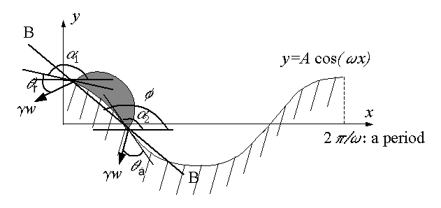

Figure 1.
Micro-Droplet Movement by Programmed Wavy Surface
Li et al.
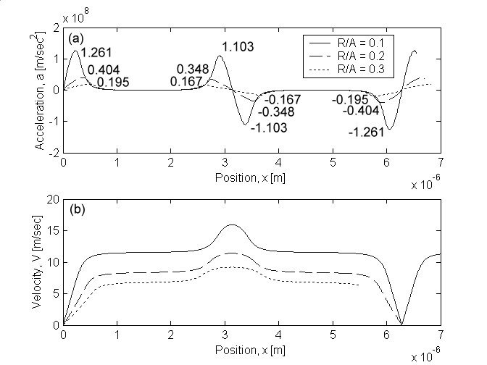

Figure 2.
Micro-Droplet Movement by Programmed Wavy Surface
Li et al.
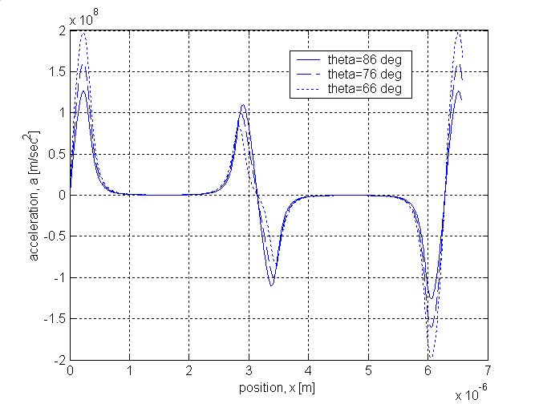

Figure 3.
Micro-Droplet Movement by Programmed Wavy Surface
Li et al.
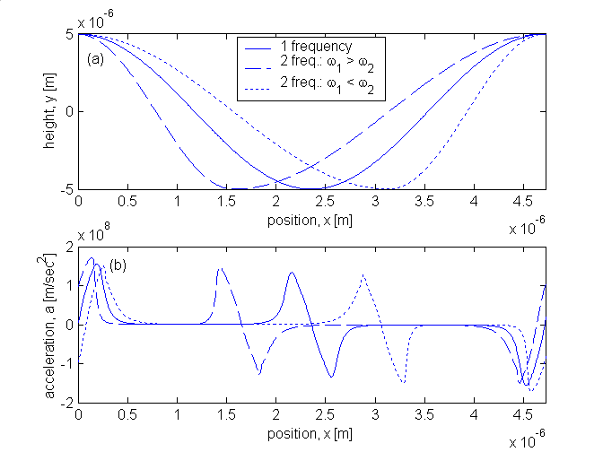
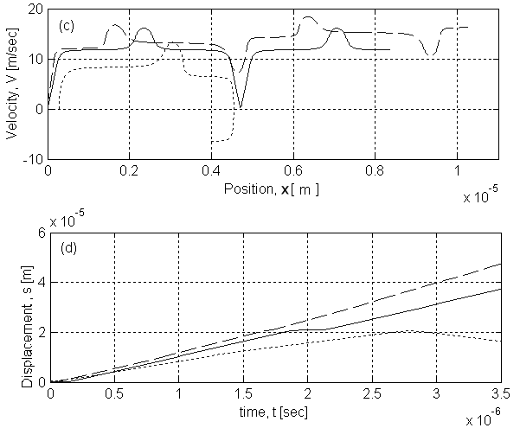

Figure 4.
Micro-Droplet Movement by Programmed Wavy Surface
Li et al.
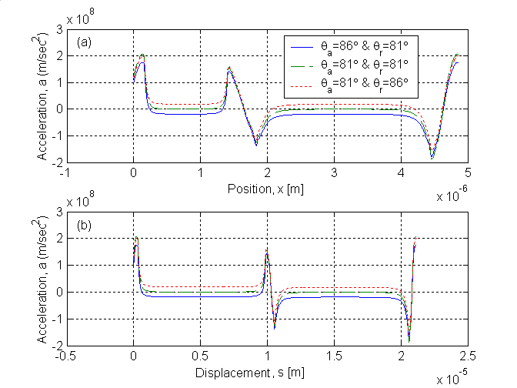

Figure 5.
Micro-Droplet Movement by Programmed Wavy Surface
Li et al.
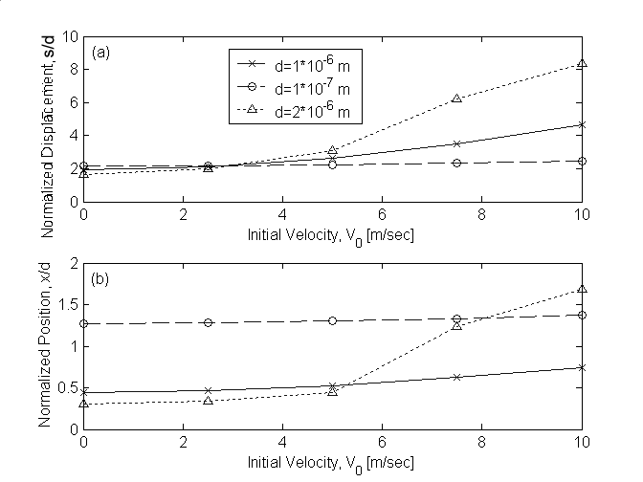

Figure 6.
Micro-Droplet Movement by Programmed Wavy Surface
Li et al.
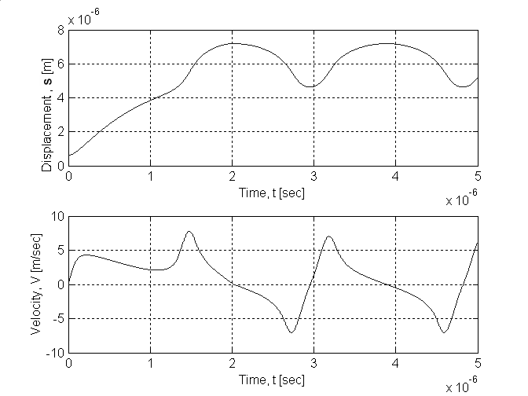

Figure 7.
Micro-Droplet Movement by Programmed Wavy Surface
Li et al.
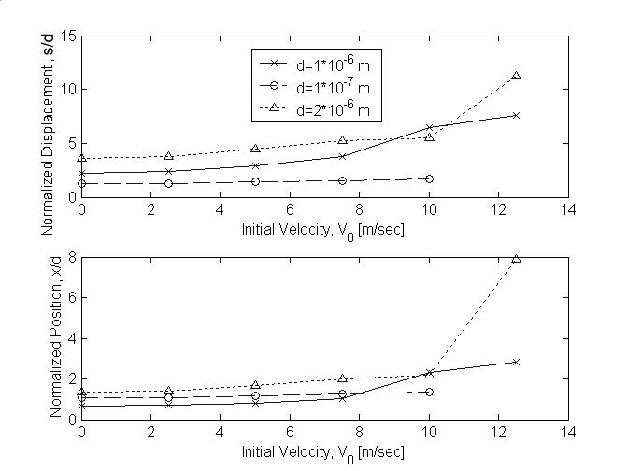

Figure 8.
Micro-Droplet Movement by Programmed Wavy Surface
Li et al.
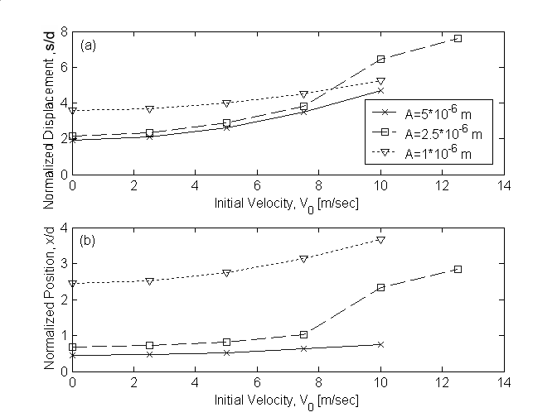

Figure 9.
Micro-Droplet Movement by Programmed Wavy Surface
Li et al.

