Title: Numerical Simulation for Micro-Droplet Movement due to Marangoni Effect

Short Title: Numerical Simulation for Micro-Droplet Movement

Authors: Fan-Gang Tseng, Kuo-Tong Ma, Yuan-Tai Tseng, and *Ching-Chang Chieng
* Department of Engineering and System Science, National Tsing Hua University, Hsinchu, Taiwan, 30043, Tel: +886-35-716691, Fax: +886-35-720724, email: cchieng@mx.nthu.edu.tw

Abstract
This work explores the phenomenon of a micro-liter droplet moving on a surface subjected to a temperature gradient by numerical simulations. First principle equations similar to homogenous flow model used in two phase flow calculation in cooperation with Volume-of-Fluid (VOF) interface tracking methodology and Continuum Surface Force (CSF) model are employed. The computations are employed for an 1 μ droplet with 1.6 mm curvature radius and 45° contact angle on based surface under temperature gradient of 20°C/m. The computational results illustrate that Marangonic effect drives the droplet moving toward cold region with the speed of 4 cm/s after droplet forms a shape with a blunt tail and a sharp nose. This study suggests an option for energy conversion from thermal energy to kinetic energy by the use of surface tension force.

- Introduction
Miniaturization of engineering system is an emphasis in the recent years, study of microscale phenomena and the transport of mass, energy, and/or charge is important in designing new devices. As the system gets smaller, surface properties play more important roles. Identifying micro/nano energy source, micro-scale energy conversion, as well as controlling small liquid droplet movement, etc. are of interest. This work proposes the conversion from thermal energy to kinetic energy of a tiny liquid droplet via the application of the temperature gradient on the base of the droplet. Temperature heterogeneity inside the liquid droplet is constructed resulting from heat transport from the temperature heterogeneity on the based surface. The surface tension caused by the Marangoni effect may lead to a tangential stress at the droplet interface and pushes the droplet from the warm region (low-surface tension) to the cold region (high-surface-tension). There are various means to move the tiny droplet such as Marangoni effect [1], pressure difference applied across a droplet [1], electrostatic traveling wave [2], or asymmetrically structured surfaces [3]. Computational models for the possible mechanisms are always the fast way to obtain basic understanding and physics. Furthermore, the droplet movement by Marangonic effect has been introduced and observed by Wasan et al [4] and Daniel et al [5]
In the present study, solving first principle equations is the key to simulate the movement and deforming process of the droplet numerically so that the unnecessary assumptions and simplifications can be eliminated.

2. Numerical Simulation Approach
Present study chooses Volume-of-Fluid (VOF) method [6,8] for two phase homogenous flow model [10] and the interface tracking technique in cooperation with CSF surface tension model [7]. Under the assumption of incompressibility, the volume fraction F obeys the continuity equation:
$\frac{∂F}{∂t}+{\vec{U}}_{m}⋅∇F=0$ (1)
where U_{m} is the velocity of the liquid-gas mixture.
The conservation equations of mass and momentum are the first principle equations to be solved, and they must be incorporated with PLIC-VOF Interface Tracking Methodology to capture the interface. The equations can be expressed as follows:
Continuity equation
$\frac{∂ρ_{m}}{∂t}+∇⋅\left(ρ_{m}{\vec{U}}_{m}\right)=0$ (3)
Momentum equation
$\begin{aligned}\frac{∂ρ_{m}{\vec{U}}_{m}}{∂t}+∇⋅\left(ρ_{m}{\vec{U}}_{m}{\vec{U}}_{m}\right)=−∇P+ρ_{m}\vec{g} \\ \begin{matrix} & \end{matrix}+∇⋅\left(μ_{m}∇U_{m}\right)+{\vec{F}}_{\text{sv}}\end{aligned}$ (4)
${\vec{F}}_{\text{sv}}$ in Eq.(4) is the volumetric surface tension force which can be calculated by CSF (Continuum Surface Force) model [9] as follows:
${\vec{F}}_{\text{sv}}={\vec{f}}_{\text{sv}}δ_{s}$ and ${\vec{f}}_{\text{sv}}=\text{σκ \{}\vec{n}+∇_{s}σ$ (5)
${\vec{f}}_{\text{sv}}$ is the surface tension per unit interfacial area, $δ_{s}$ is the surface data function, $σ$ is the surface tension coefficient, $κ=−∇⋅\vec{n}$ is the curvature of interface, and $\vec{n}$ is the unit normal vector estimated from volume fraction gradient $\vec{n}=\frac{∇F}{\left|∇F\right|}$, is the important key for the accuracy of interface tracking algorithm.. The interface is determined employing PLIC-VOF Interface Tracking Methodology [2,3]. At any point, ${\vec{r}}_{0}$, in the cell is sorted into three regions by the interface equation:
${\vec{r}}_{0}⋅\vec{n}−c$$\left\{\begin{matrix}0 \\ 0 \\ 0\end{matrix}\right.\begin{matrix} \\ \\ \end{matrix}$ (6)
The least square gradient that minimize the sum of square Taylor serial expansion of volume fraction minus other neighborhood volume fraction, $\text{min}$, is applied to achieve second order accuracy of calculating$∇F$ in space. For a given constant c, the truncation volume that the fraction of cell volume truncated by interface can be derived from the interface equation Eq. (6) by a complicate geometric manipulation. However, the constant c is approximated by equivalent the truncation volume to the volume fraction of the cell. An iteration procedure of c is required for resolving the interface location that reconstructed the interface from the volume fraction of the cell. Once the interface is depicted, the volume fluxes and the integrated of volume fraction in can be calculated with the time marching technique. Recently, Wang et al [11] robust the PLIC-VOF method by separating the pressure gradient term for an interface cell into liquid and gas components so that the non-physical “parasitic current” can be eliminated

3. Results and Discussions
It is a 3-D simulation giving detailed, quantitative parameters; however, tremendous grid numbers are needed for accurate computations. Two grid systems are employed to check the grid-independency and the reliability of the computational results for an 1 μ droplet with 1.6 mm curvature radius and 45° contact angle on based surface under temperature gradient of 20°C/m: (1) rectangular grid of 66×21×15 points (Fig.1), and (2) finer rectangular grid of 138×31×21 points (Fig.2). Figure 3 plots the ratio of the droplet base diameter (D) during process and initial droplet base diameter (D_{o}) as the heating process proceeds and the variation of D/D_{o} shows that the droplet experiences “compression-relaxation” cycles at the first stage and roughly the same finalized size are obtained although the processes are different apparently in cycles. Figure 4 displays the changing process of the droplet deformation and its movement using coarse grid. The droplet stays the same position for 21.75 ms and performs “compression-relaxation” oscillation with 120 Hz before Marangoni effect dominating the droplet movement. Marangoni effect drives the droplet moving peristaltic toward cold region with the speed of 4 cm/s after droplet forms a shape with a blunt tail and a sharp nose. Other interesting observations other than droplet progression from computations include (1) the small amount of water content on the surface forms numerous disconnected droplets as observed in ref. [5], (2) a number of air vortices generated around the droplet and performs conjugated convective/conduction heat transfer (3) tension distribution in the entire flow domain, which directs the movement of the droplet. Figure 5 illustrates the similar dynamic process using the finer grid although more cycles of “compression-relaxation” oscillations for a period of 30 ms are needed before the droplet becomes asymmetry and starts to move. 4.57 cm/sec of the droplet moving speed is obtained by using finer grid, which is slightly higher than the value obtained by using coarser grid. Most important conclusion is that both computations reveal the same physics.

4. Conclusion
The computations suggest that the supplied thermal field with large temperature gradient can be employed as an energy source to move a nano-liter-scaled liquid droplet via Marangoni effect. The efficiency of the energy conversion and the false numerical diffusion effect need to be further studied.

References
[1] M.A. Burns, B.N. Johnson, S.N. Brahmasandra, K. Handique, J.R. Webster, M. Krishnan, T.S. Sammarco, P.M. Man, D. Jones, D. Helsinger C.H. Mastrangelo, and D.T. Burke (1998) An Integrated Nanoliter DNA Analysis Device, Science, Vol. 282, p. 484-487.
[2] M. Washizu (1998) Electrostatic actuation of liquid droplets for microreactor applications, IEEE Trans. Ind. Appl. Vol. 34, p.732-737.
[3] O. Ssandre, L. Gorr-Talini, A. Ajdari, J. Prost, and P. Silberzan (1999) Moving Droplets on Asymmetrically Structured Surfaces, Physical Review E, Vol. 60, No.3, p. 2964-2972.
[4] Darsh T. Wasan, Alex D. Nikolov, and Howard Brenner (2001) Droplets Speeding on Surfaces, Science, Vol. 291, p. 605-606.
[5] Susan Daniel, Manoj K. Chaudhury, John C. Chen (2001) Fast Drop Movements Reuslting from the phase change on a Gradient Surface, Science, Vol. 291, p. 633-636.
[6] D. B. Kothe, W. J. Rider, S. J. Mosso, and J.S. Brock (1996) Volume Tracking of Interfaces Having Surface Tension in Two and Three Dimensions, 34th Aerospace Science Meeting and Exhibit, AIAA-96-0859
[7] J. U. Brackbill, D. B. Kothe and C. Zemach (1992) A Continuum Method for Modeling Surface Tension, J. Comp. Phys., Vol. 100, p. 335-354.
[8] W. J. Rider and D. B. Kothe (1998) Reconstructing Volume Tracking, J. Comp. Phys., Vol. 141, p. 112-152.
[9] Koji Takahashi, Jian-Gang Weng, and Chang-Lin Tien (1999) Marangoni Effect in Microbubble Systems, Microscale Thermophysical Engineering, Vol. 3, p. 169-182.
[10] Ishii, M. (1975) Thermo-fluid Dynamic Theory of Two-phase Flow, p. 202-233, Eyrolles, Paris
[11] Wang, D.M. Bayyuk, S. and Lowry, S. A. (2001) A Self-consistent, Higher-order Accurate Scheme for the VOF Methodology for Multi-phase Flows, to be present

Acknowledgements
The authors would like to thank National Science Council of Republic of China for their support under contract NSC-90-2212-E-007-56

Captions of Figures
Figure 1. Computational Grid of 66x21x15
Figure 2. Computational Grid of 138x31x21
Figure 3. The Size Change of the Droplet during Heating Process
Figure 4. Droplet Deformation and Movement Process as It Sits on a Surface with Temperature Gradient (Grid system of 66x21x15)
Figure 5. Droplet Deformation and Movement Process as It Sits on a Surface with Temperature Gradient (Grid system of 138x31x21)

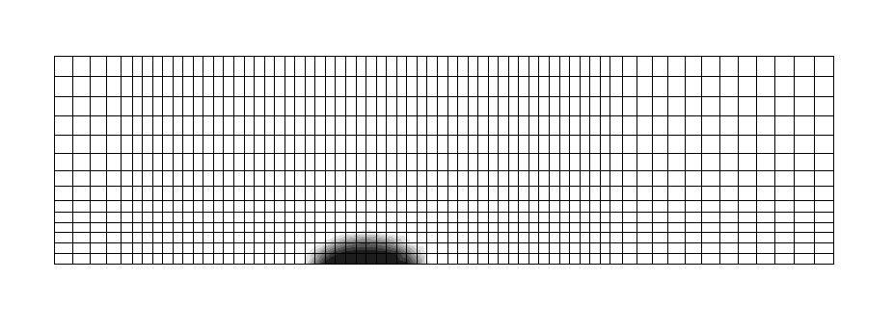

Figure 1.
Numerical Simulation for Micro-Droplet Movement due to Marangoni Effect
Tseng et al.

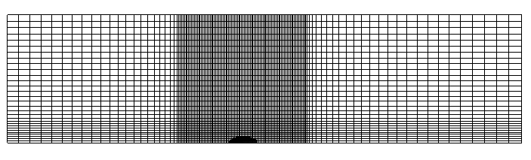

Figure 2.
Numerical Simulation for Micro-Droplet Movement due to Marangoni Effect
Tseng et al.

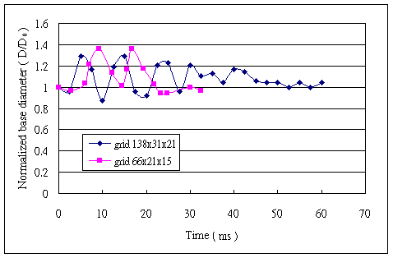

Figure 3.
Numerical Simulation for Micro-Droplet Movement due to Marangoni Effect
Tseng et al.

( a ) initial stationery state, t=0
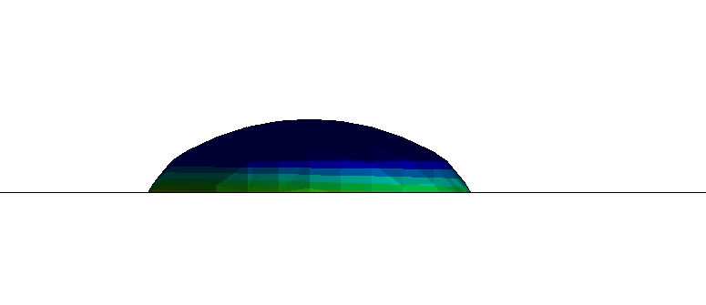
( b ) compression, t=2.75 ms
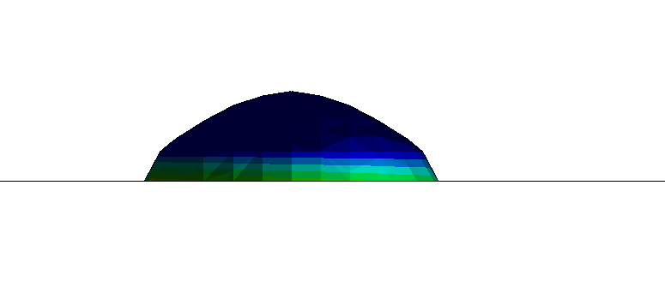
( c ) spreading, t=9.25 ms
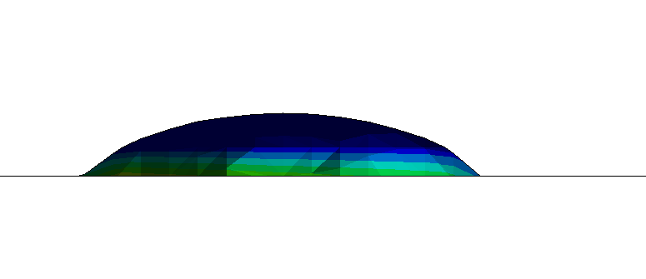
( d ) compression, t=12.75 ms
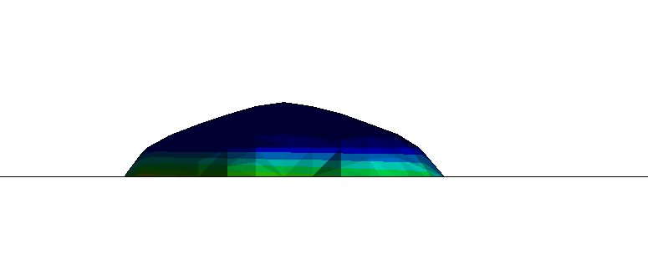
( e ) spreading, t=16.75 ms
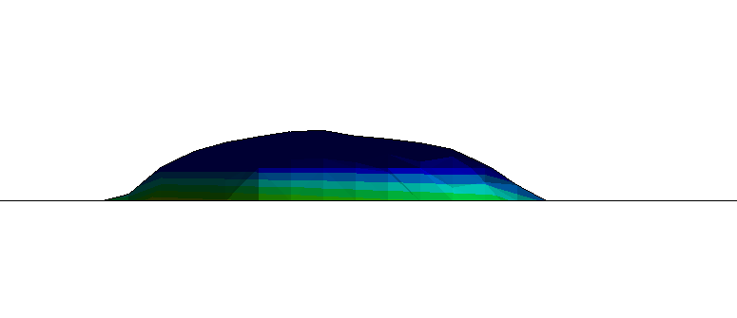
Figure 4.
Numerical Simulation for Micro-Droplet Movement due to Marangoni Effect
Tseng et al.

( f ) asymmetry observed, t=21.75 ms
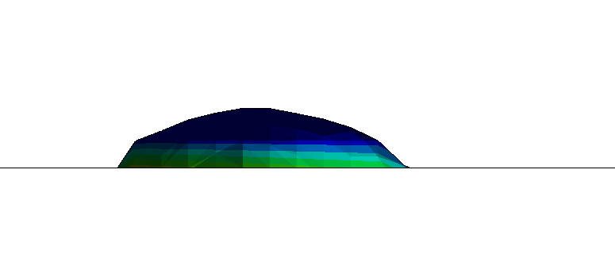
( g ) droplet moving, t=23.25 ms
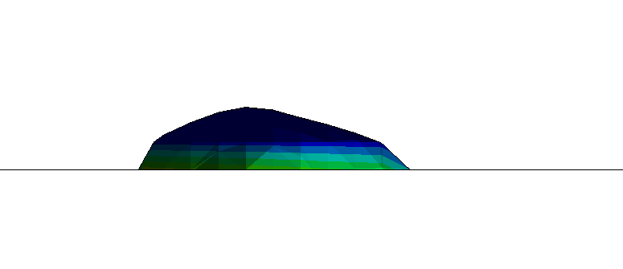
( h ) t=24.75 ms
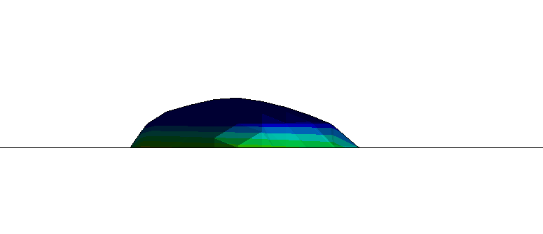
( i ) t=30 ms
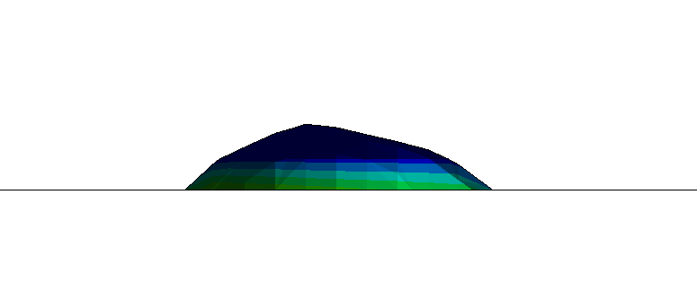
( j ) t=32.5 ms
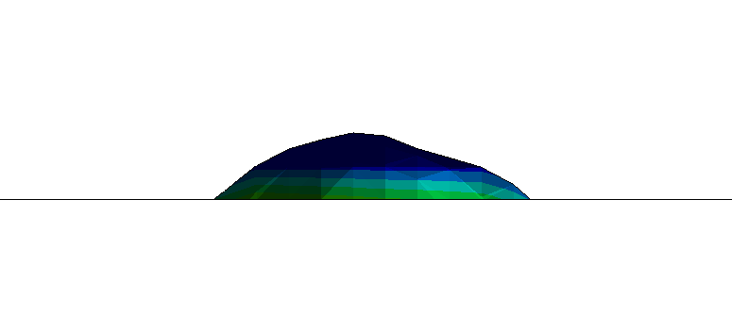

( a ) initial stationery state, t=0 ms
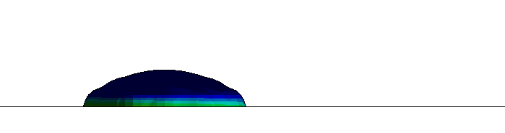
( b ) compression, t=2.5 ms
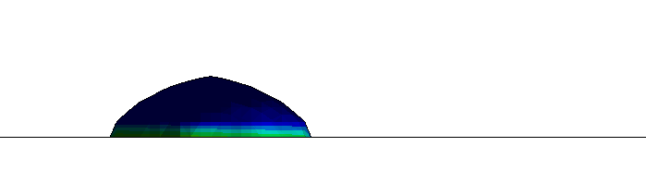
( c ) spreading, t=5 ms
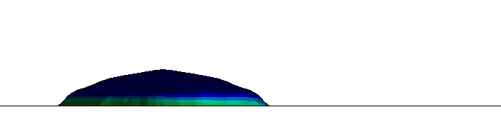
( d ) compression, t=10 ms
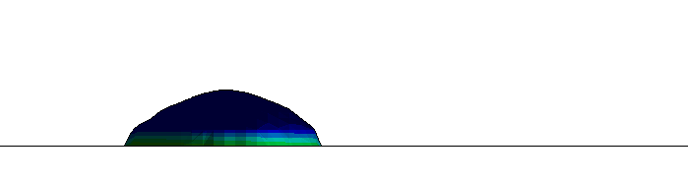
( e ) spreading, t=15 ms
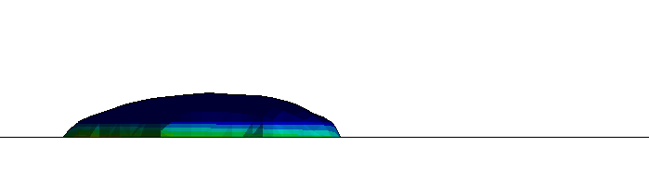
( f ) compression, t=20 ms
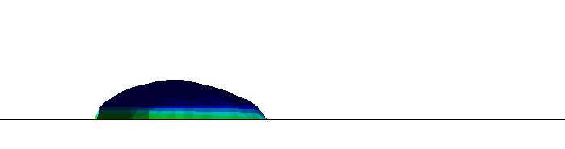
( g ) asymmetry observed, t=25 ms
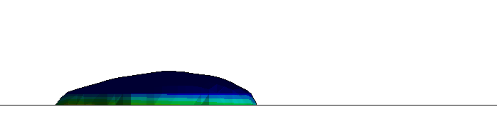
Figure 5.
Numerical Simulation for Micro-Droplet Movement due to Marangoni Effect
Tseng et al.

( h ) droplet moving, t=30 ms
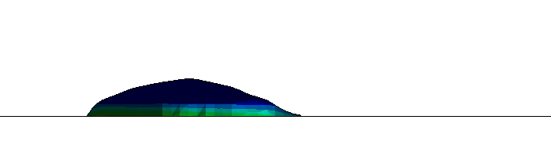
( i ) t=35 ms
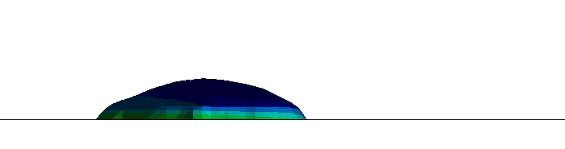
( j ) t=40 ms
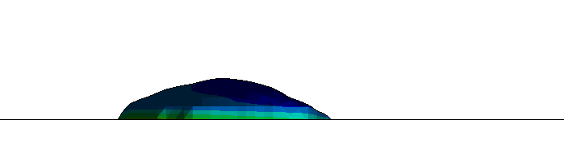
( k ) t=45 ms
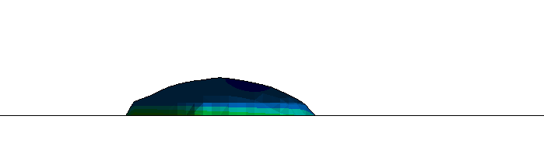
( l ) t=50 ms

( m ) t=55 ms
( n ) t=60 ms


