BLOCKING PHENOMENON OF ICE/WATER SLURRY AT THE TUBE ORIFICE

HIROCHI Takerou, YAMADA Shuichi, SHINTATE Tuyoshi and SHIRAKASHI Masataka
Department of Mechanical Engineering, Nagaoka University of Technology
1603-1 Kamitomioka, Nagaoka 940-2188, Japan

INTRODUCTION

A new cold energy transportation system utilizing ice/water mixture flow is under development for the purpose of raising cold energy density in district cooling systems. Many experimental works¹⁻² have been carried out to clarify the flow and heat transfer characteristics of ice/water slurry and to develop devices and instruments to be applied to the system. As a result of these works, it is reported that the blocking of pipe element such as a reducer, valve and distribution manifold is likely to occur due to the compressed ice particle cluster. This type of blocking is quite different in the nature from blocking due to the arching or the deposition observed in usual solid-particle/water slurry transportation pipelines. It is guessed that the adhesive nature of ice-particle is the main cause of the blocking of ice/water slurry. However, very few works have been carried out so far on the ice particle blocking and no data is reported on the adhesion force of the ice particles in water to be correlated with this phenomenon. The specific aim of this work is to clarify the mechanism of the blocking of ice/water slurry flow at an orifice in a pipeline and to find a criterion for the occurrence of the blocking of ice/water slurry.

EXPERIMENTAL APPARATUS AND PROCEDURE

The experiment for blocking is composed of the element test using the apparatus shown in Fig.1 and the pipeline test. In the former, ice-particle/water mixture filling a transparent pipe is driven out through the test orifice by a piston-cylinder device. The blocking process is observed and recorded by a video. Fig.2 shows the details of test section. Pressures p₁ and p₂ at the locations in Fig.2 and the ice fraction C upstream the orifice are detected. Electrodes for ice fraction measurement are attached at the position A. The electrodes are removed for the observation test.
This test section is used in the pipeline test, too. Four classes of particles are used as the sample: chip ice (mean particle size d_{p}=10mm, ρ=917kg/m³), granulated snow (d_{p}=3mm, ρ=917kg/m³), fresh snow (d_{p}=1mm, ρ=917kg/m³) and polypropylene beads (d_{p}=4mm, ρ=908kg/m³).
Fig.1 Schematic diagram of apparatus
for the element test
1.Video camera
2.Water bath
253Bx1605Lx500H
3.Test section
4.Fraction meter
5.Pressure gauge
6.Personal computer
7.Hydraulic unit
8.Hydraulic cylinder
9.Piston-cylinder
10.Position meter
5.
7.
8.
10.
1.
2.
3.
4.
6.

9.
Fig.2 Details of test section
□100
254
( 985 )
φ52
φ60
Electrode for ice fraction measurement
: pressure hole φ1
Orifice φ15
10.5
85.5
10
p₂
p₁
A

Test particles are weighted and put into the test section uniformly along the pipe axis. The range of the velocity u is 0~1m/s, and initial particle fraction C₀ is 0~32%. The compressive yield stress of each ice particle is measured by adding a load abruptly to the cylindrical test piece (a cluster of particles with diameter 65mm and length 65mm).

RESULTS AND DISCUSSIONS

Photographs in Fig. 3 (a) and (b) show the blocking of the beads and the chip ice slurries, respectively. In the case of these non-adhesive particles, the particle fraction C increases steeply and soon attains a constant value nearly equal to that of the natural packing. When the orifice diameter d_{o} is larger than a certain critical value, i.e. d_{o}>10 mm for the beads and d_{o}>25mm for the chip ice, no blocking occurs irrespective of the initial fraction C_{o} and the flow velocity u. The particle cluster cannot keep its shape and particles separate each other when removed out of the test pipe. Hence, the blocking of these particles is considered to be caused by the arching.

In the case of the fresh snow and the granulated snow, the blocking occurs when d_{o}<15 mm as seen in Fig. 3 (c) and (d). The fraction C and the pressure difference p₂-p₁ increase gradually after a small snow particle cluster stagnated at the orifice until a plug-like particle cluster filling the pipe is formed. The particle-plug has considerable strength like a solid column as seen in the bottom frames of photographs in Fig.3 (c) and (d). Hence, we call this type of blocking "compressed plug type blocking".
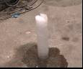
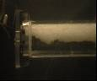
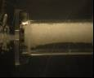
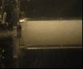
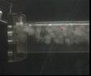
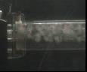
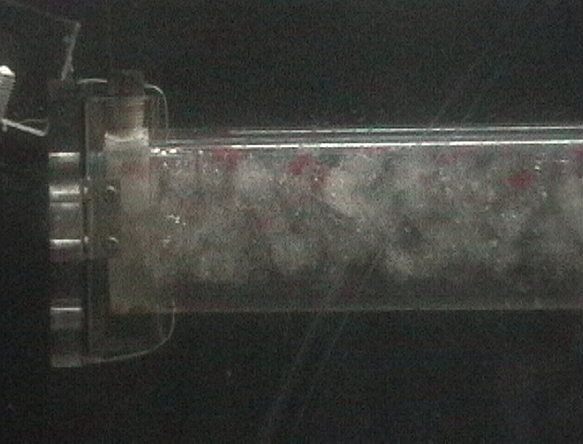
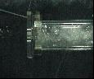
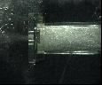
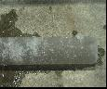
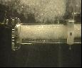
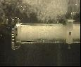
Fig.3 Blocking at orifice ( flow direction)
t ≤ 0s
t = 0.33s
t = 0.83s
t ≤ 0s
t = 0.75s
t = 2s
t ≤ s0
t ≤ s0
t = 0.83s
t = 1s
produced cluster
produced cluster
Beads
u=0.42m/s,C₀=35%
(b) Chip ice
u=0.13m/s,C₀=25%
Granulated snow
u=0.18m/s,C₀=35%
Fresh snow
u=0.13m/s,C₀=31%
Since the adhesive nature of ice particles in water is considered to be a governing factor for the compressed plug type blocking, it is estimated by the compressive yield stress obtained through a compression test on a cylindrical particle cluster sample in water. The ratio of the maximum orifice diameter for the blocking to the particle size is plotted against the compressive yield stress in Fig. 4. This result infers that the adhesive nature of the particles is the dominant factor for the blocking.
15
10
5
0
0
1
2
Yield stress (kPa)
Fig.4 Blocking diameter ratio
Chip ice
Bead
Granulated snow
Fresh snow
Diameter ratio (-)
The criterion for the compressed plug blocking of the granulated snow obtained through the element test is presented in Fig.5 (a) as a curve on the u-C_{o} plane. At a velocity u lower than a certain value, stagnation of the particle cluster occurs for the lowest value of C_{o}. Since the stagnation may lead to the blocking if the orifice is installed in a pipeline for the cold energy transportation, this velocity is taken as the threshold for the non-blocking condition. In the case of the fresh snow, the threshold value of u is higher as seen by comparing Fig.5 (a) and (b).
:particles pass through :particles stagnate
:blocking observed :blocking occurs every time
:stagnate in pipeline + :pass through in pipeline
:criterion curve
40
30
20
10
0
0
0.1
0.2
0.3
0.4
0.5
C₀(%)
u (m/s)
40
30
20
10
0
0
0.1
0.2
0.3
0.4
0.5
C₀(%)
u (m/s)
(b) Fresh snow d_{p}=1mm, d_{or}=15mm
Granulated snow
d_{p}=3mm, d_{or}=15mm
Non-blocking region
Fig.5 Blocking condition

The blocking was examined on the orifice in a pipeline of a slurry transportation system, and the results are compared in Fig. 5 (b) with those of the element test. The criterion curve by the latter seen to present the condition for the occurrence of the blocking of ice/water slurry in a pump-pipeline system.
準備段階

CONCLUSIONS

(1) The main cause of compressed plug type blocking is the adhesive nature of ice-particle.
(2) The critical curves of blocking at the orifice are introduced in the element test.
(3) The critical condition for the blocking in a pipeline system agrees well with the criterion obtaind by the element test.

REFERENCES

- Kawada, Y., Shirakashi, M., and Yamada, S., Characteristics of Ice/Water Slurry in a Horizontal Circular Pipe, Proceedings of 3rd ASME/JSME Joint Fluids Engineering Conference, San Francisco, USA, July 18-22, 1999, FEDSM-7781
- Umemura, T., Nakayama, M., Uchiyama, A. Tokunaga, Y. and Shirakashi, M., Blocking of Snow/Water Mixture Flow and Criterion of Stagnation of Snow at Pipe Orifice, J. Japanese Society of Snow and Ice, Vol.48, No.4, pp207-214, 1986.

