TEMPERATURE AND FLOW VISUALIZATION IN A SIMULATION OF THE CZOCHRALSKI PROCESS USING TLCs

Jelena Aleksic, Paul Zielke and Janusz A. Szymczyk
University of Applied Sciences of Stralsund
Department of Thermofluiddynamics and Turbo Machines
Zur Schwedenschanze 15, 18435 Stralsund, Germany

Nowadays there is no doubt that thermal and thermocapillary convection play the dominant role in impulse, heat and material transfer in the Czochralski crystal growth method. Because of the complexity of the problems, measurements in one point of the volume are not inefficient to understand the flow topography and to compare the experimental results with the real or numerically simulated ones. Therefore it is of great interest to measure the temperature and velocity in the whole field to qualitatively analyse the thermally driven convections. With this aim, a new experimental method (PIT) was developed, which is based on the computer-aided colour analysis of the temperature-sensitive liquid crystals (TLCs), the use of which enables the temperature and velocity fields to be determined simultaneously.

INTRODUCTION

In the Czochralski crystal growth method, a polycrystalline structure is melted in the crucible at a temperature that is a little higher than the melting point. Then a germ bud is brought on to the surface of the melt. The melt gets solid at the germ bud and obtains its monocrystalline structure. The growth of the monocrystal into the melt is prevented by slowly and uniformly pulling the monocrystal from 0.1 to 100 mm/h and rotating it at between 1 to 100 rpm. A regular crystal rod is built up and new layers are attached to it. To increase the quality of the crystal and to optimise the process, it is necessary to investigate which types of convection occurs in the parameters range and under which conditions transient convection appears.

OPTICAL FLOW MEASUREMENT SYSTEMS

The aim of the measurement systems with Particle Image Thermometry (PIT) is the quantitative determination of the temperature field in a convective flow. PIT is based on the property of certain liquid crystals (with a diameter of 10 – 100 μm) to reflect light in different colours depending on their temperature and the observation angles and it is used in the Czochralski method simulation parallel to the Particle Image Velocimetry (PIV). In PIT, the lightsheet from the white light source is recorded with a digital camera. The light source for a 1.5 mm thin lightsheet is a halogen lamp. The evaluation methods and their software were successfully developed by us. The same TLCs are used in PIV as tracers for determining the flow velocity. Figure 1 shows the layout of the optical flow measurement systems in the experimental equipment.

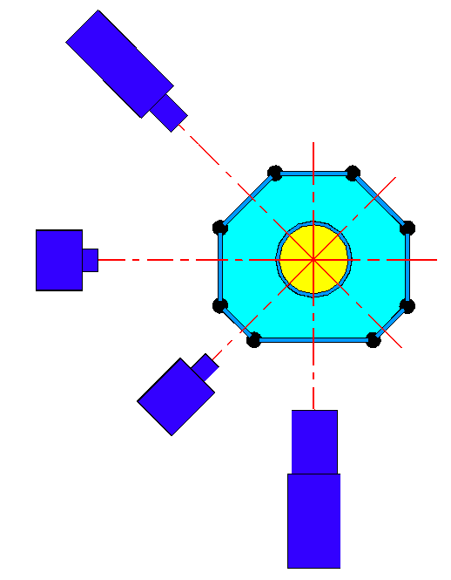
Digital camera
Lens system for producing laser-lightsheet
Lens system for producing white-lightsheet

Surrounding bath
Experimental cubicle
Experimental fluid
Quartz-glass windows
Cross-correlation camera
Figure 1: Lightsheet method system in the experimental equipment

RESULTS

It appeared that there are three kinds of convection in the liquid:
- Marangoni convection – thermocapillary flow (effect of the liquid –air interface stress)
- Thermal convection (effect of density variations with temperature in the fluid layers)
- Forced convection (effect of the rotation)

The influence of changing the aspect ratio, Prandtl, Marangoni or rotatory Froude Number on the flow topography can be identified by changing the thermal and kinetic boundary conditions and after determining the temperature and velocity fields.

The following example (Figure 2) shows the influence of the Prandtl Number on the temperature and velocity fields. In the case of a very large Prandtl Number (Figure 2A) the temperature field is quasi-symmetrical. The large Marangoni Number suggests a strong boundary driven convection. It is also an indicator of the strong heat transfer for a decreasing Prandtl Number and therefor a larger worm flow spread trough the volume (Figure 2D). In the case of a very large Prandtl Number (Figure 2B-C), a strong Marangoni convection was build up and the velocity field is laminar and rotational-symmetrical. A swiftly, cold, downward flow (a so called jet) will be formed in the middle of the cubicle and will be reinforced trough thermal convection. The flow is steady and stable with a stable topography. A reduction of the Prandtl Number results in the destruction of the stability and flow symmetry (Figure 2E-F). A secondary temperature gradient is formed, which destroys the stable density layers and a second convection roll will be formed. For smaller Prandtl Numbers an instability flow can be expected, with an unstable devolution and permanently changing flow topography. The growing Reynolds Number also indicates this result. It has to be proved whether this flow turns into some other mode and whether it leads to an oscillatory buoyancy driven flow.
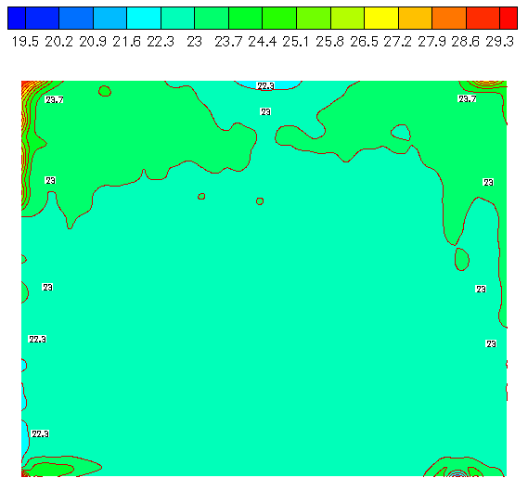  A: Temperature field | 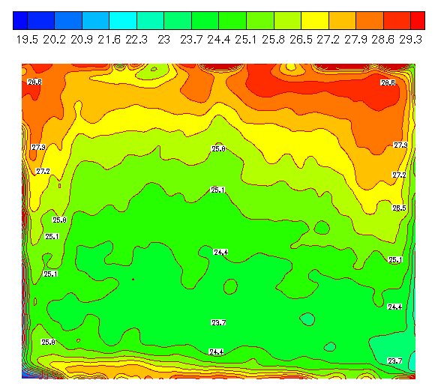  D: Temperature field
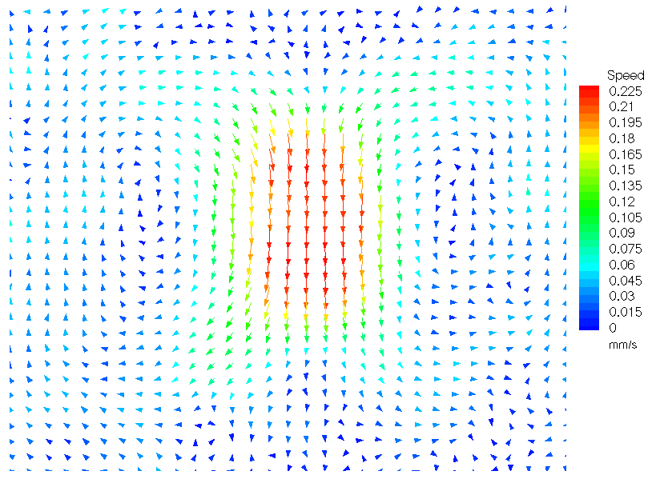  B: Velocity field | 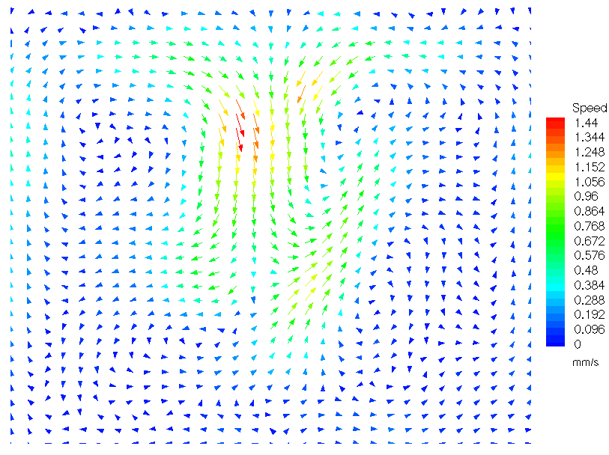  E: Velocity field
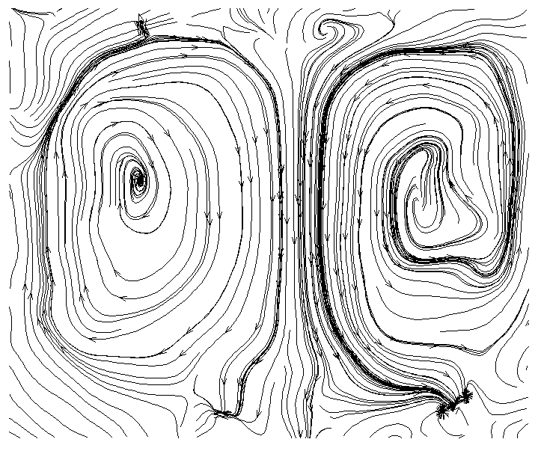  C: Streamlines | 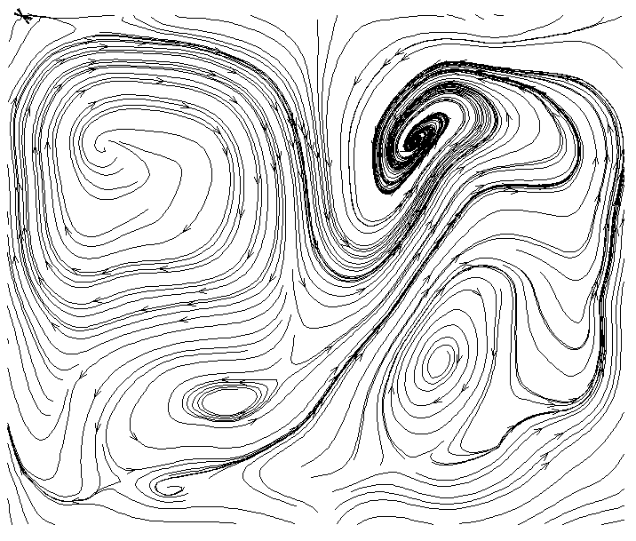  F: Streamlines
Mg = 590.9, Pr = 8226.8, Re = 0.07 | Mg = 43020, Pr = 39.66, Re = 1841.43

Figure 2: Boundary conditions with the appendant temperature and velocity fields, streamlines and the dimensionless numbers

REFERENCES

- Aleksic, J., Szymczyk, J. A., Leder, A. and Kowalewski, T. A., Experimental Investigations on Thermal, Thermocapillary and Forced Convection in Czochralski Crystal Growth Configuration, CMEM 2001, 4-6 Jun 2001, Alicante, Spain, Computational Methods and Experimental Measurements X, pp. 627-636, ISBN 1-85312-870-8, WIT Press, 2001
- Aleksic, J., Zielke, P., Szymczyk, J. A. and Delgado, A., Diagnose des Geschwindigkeits- und Temperaturfeldes in einer Czochralski Simulation, 8. Fachtagung „Lasermethoden in der Strömungsmeßtechnik – neuere Entwicklungen und Anwendungen“ GALA 2000 Tagungsband, 37, ISBN 3-8265-7809-0, Shaker Verlag 2000

